

**LIBRARY MANAGEMENT SYSTEM**

Submitted to the

Department of Statistics and Computer Science

Moi University

In Partial Fulfillment of

The Requirements for the Degree of

Bachelor of Science in Computer Science

By

**REG NO. NAME SIGNATURE**

COM/10/17 CHARLES MUNENE KITHINJI ……………...

COM/05/17 SUSAN MWIHAKI KABUGI ……………...

COM/16/17 MUKOTSO M. KELVIN ……………...

Date: ………………………

# Declaration

We declare that this report is our original work and has not been presented for a degree award in any other university. No part of this work may be reproduced without prior written permission of the authors and/ or Moi University.

**REG NO. NAME SIGNATURE**

COM/10/17 CHARLES MUNENE KITHINJI ……………...

COM/05/17 SUSAN MWIHAKI KABUGI ……………...

COM/16/17 MUKOTSO M. KELVIN ……………...

# Approval Page

**SUPERVISOR’S DECLARATION**

This project has been submitted for review with my approval as the University Supervisor.

Signature………………………………………… Date ……………………………

Name: ………………………………………………………………………………….

DEPARTMENT OF STATISTICS AND COMPUTER SCIENCE

MOI UNIVERSITY

# Dedication.

This project is dedicated to our families, friends and teachers who have been very supportive throughout the project development period and finally the society.

# Abstract

This report is about Library management system which is a software application useful for librarians in any educational institution for management and handling of typical operations in the library. It manages data through computerized system in a database which eradicates the tediousness in searching a particular book in the entire library manually. The details about the functions, design and development of the product are well described and demonstrated in this report.

# 

# Key Words and Phrases

Library management system – This is the name of the project described in this report.

LMS- library management system

DBMS – Database Management System.

HSM – hardware security model

**Table of Contents**

Declaration 2

Approval Page 3

Dedication. 4

Abstract 5

Key Words and Phrases 6

1. INTRODUCTION AND BACKGROUND 10

1.1 Statement of problem 10

1.2 Background 10

1.3 Brief Project Description 11

1.4 Purpose of Project 11

2. LITERATURE REVIEW 12

2.1 Previous and Current work 12

3. SYSTEM FUNCTIONAL SPECIFICATION 14

3.1 Functions Performed: 14

3.1.2 The Administrator Module Functional Specifications 14

3.1.2 The Librarian Module Functional Specifications 15

3.2 User Interface Design: 16

3.3 System Database/File Structure Preview: 26

3.4 External and Internal Limitations and Restrictions: 28

3.5 User Interface Specification: 28

3.5.1 User Screens/Dialog: 28

3.5.2 Report Formats/Sample Data: 31

3.5.3 Error conditions and system messages: 33

3.5.4 Control Functions: 34

4. SYSTEM PERFORMANCE REQUIREMENTS 35

4.1 Efficiency 35

4.2 Reliability 36

4.2.1 Description of Reliability Measures 36

4.2.2 Error/Failure Detection and Recovery 36

4.2.3 Allowable/Acceptable Error/Failure Rate 36

4.3 Security 36

4.3.1 Hardware Security 36

4.3.2 Software Security 37

4.3.3 Data Security 37

4.3.4 Execution Security. 37

4.4 Maintainability 37

4.5 Modifiability 37

4.6 Portability 38

5. SYSTEM DESIGN OVERVIEW 39

5.1 System Data Flow Diagrams 39

5.2 System architecture and structure 41

5.3 System Data Dictionary 42

5.4 Description of System Operation. 46

5.6 Implementation Languages 47

5.7 Required Support Software (Pre-Existing) 47

6. SYSTEM DATA STRUCTURE SPECIFICATION 48

6.1 User Input specification 48

6.1.1 Identification of user input data. 48

6.1.2. Sources of input data (Not Input devices) 48

6.1.3. Input medium and/or Devices 49

6.1.4. Data format/Syntax. 49

6.2 User output Specification 49

6.2.1 Identification of output data 49

6.2.2 Output Medium and/or device. 50

6.2.3 Output format/Syntax 50

6.2.4 Output Interpretation 50

6.3 system database /file structure specification 51

6.3.1 Identification of Data Base/Files 51

6.3.2 Subsystems Accessing the Database 51

6.3.3 Logical File Structure 51

6.3.4 Physical File Structure 51

6.3.5 Data Base Management Subsystems Used (internal or external) 51

7. MODULE DESIGN SPECIFICATIONS 52

7.1 add librarian Module. 52

7.1.1 Module Functional specification 52

7.1.2 Module operational Specification 52

7.2 Issue book module 53

7.2.1 Module Functional specification 53

7.2.2 Module operational Specification 54

7.3 Update administrator details Module 55

7.3.1 Module Functional specification 55

7.3.2 Module operational Specification 55

7.4 librarian login module 56

7.4.1 Module Functional specification 56

7.4.2 Module operational Specification 56

7.5 Student registration Module 57

7.5.1 Module Functional specification 57

7.5.2 Module operational Specification 57

8 SYSTEM VERIFICATION. 59

8.1 Items/Functions to be tested 59

8.2 Description of Test Cases 59

8.3 Justification of Test Cases 62

8.4 Test Run Procedures and Results 63

8.5 Discussion of Test Results 73

9. CONCLUSIONS 74

9.1 Summary: 74

9.2 Problems Encountered and Solved: 74

9.3 Suggestions for Better Approaches Problem /Future Extensions to Project: 74

10. BIBLIOGRAPHY 75

11. PROGRAM LISTINGS 76

12. USER MANUAL 105

12.1 Administrator Section 106

12.2 Librarian Section 112

# 1. INTRODUCTION AND BACKGROUND

## 1.1 Statement of problem

Library Management has faced many problems in universities, colleges or any similar educational institutions to maintain large amount of data of books through traditional and manual systems. Students need not search the entire library to find a book.

Student has to visit the college to initialize the process of reservation and/or borrowing.

Data inconsistency may arise in the case of several entries of the same book and in addition whenever a new book is added in the library system. Also due to tear and loss of issue cards, it is required to make a new library card as soon as possible. Again it is time consuming task to find out the information about that particular book

The current manual system is labor intensive hence requires a number of librarians. Updating the details of student/book is a longer process and hard to maintain backup because of large and duplication of data

## 1.2 Background

Students need not search the entire library to find a book. Students have to visit the college to initialize the process of borrowing.

While issuing the book to the students, first of all one of the staffs working as a librarian asks the students to show the school ID card that has already been made by the institution for each and every student. If the student does not have the school ID card, then they never issue the book to that particular one. The librarian takes the school ID card and holds it until the student returns the book. In the register, all the information related to the students as well as the book such as registration number, student’s name and contact details, book title, book author, issue date, return date etc.

To keep record of the new book, the library staff needs to fill a form named ‘Add New Book’ in which there are number of headings to be filled up such as ‘Name of Book’, ‘Date of Delivery’, ‘Book Title’, ‘Author Name’, ‘Published Date’, ‘Published Year’, ‘Edition’, ‘Book Category’, etc.

The librarian works on keeping the record of penalty paid by the student on not giving back the book on time. Librarian finds out the issue date and return date of the book and if the student fails to return that book within the return date of the book, then he/she has to pay Ksh.10/day as a fine. The fine may get high in the case when the book has been lost or damaged by the student.

The book record is deleted from the library register book when the book has been lost or totally damaged by the user.

## 1.3 Brief Project Description

Library Management System is a software application useful for librarians in small to medium-sized educational institutions for management and handling of typical operations in the library. It manages data through a computerized system which eradicates the tediousness in running the day to day operations in the library.

The project Library Management System is developed in JAVA, which mainly focuses on basic operations in a library like adding new librarians, new books, registering students, updating new information, searching books and a facility to issue and return books.

## 1.4 Purpose of Project

* It provides "better and efficient" service to librarians.
* Reduce the workload of librarians.
* Faster retrieval of information about the desired book.
* Provide facility for proper monitoring, reduce paper work and provide data security.
* All details will be available on a click for both the system administrator and librarians.

# 2. LITERATURE REVIEW

## 2.1 Previous and Current work

Technologies that focus on supporting traditional library services no longer meet the needs of libraries that wish to strengthen their involvement in new service areas. Academic libraries are looking beyond efficiencies in collection management or improvements in library-provided discovery services. Instead, they are addressing broader education needs by inserting relevant resources into platforms that support the curriculum and enhance their institutions’ research activities. Public libraries seek technologies that improve engagement with their communities. These libraries value reliable and feature-rich automation systems, and they are especially drawn to those that help them deliver compelling digital services. Basic library resource management and discovery capabilities no longer differentiate competitors in this market of mature products.

The library management system is an original product of its kind. The basis of the whole project was raised from methods such as:

**Surveys**

Surveys made it possible to reach a large audience within a short amount of time. Because the survey was provided to individuals and not performed in a group setting, the returned results were unbiased. This was an economical technique that draws from the participant’s personal experiences. This method does not require overseeing the process and participants can participate at their convenience. All responses were submitted promptly.

**Interviews**

Interviews made it possible for effective, economical and wide reaching. The interview consisted of collection of questions and ideas for consideration. This was mass distributed with instructions for directions and guidelines. We interviewed various stakeholders such as the library staff. This promoted the individual explanation of the purpose, process and constraints for the projects. Interviews, like the surveys, made it possible to reach a large audience within a short amount of time.

**Questionnaires**

A document with pre-defined set of objective questions and respective options was handed over to all stakeholders to answer, which were collected and compiled.

**Task analysis**

We analyzed the operation for which the new system is required. We analyzed software that were already available in the library to perform certain operation and we collected the requirements of proposed system.

**Observation**

We visited the library workplace and observed the actual working of the existing installed systems. We observed the workflow at client’s end and how execution problems are dealt with. We drew some conclusions which aided to form requirements expected from the proposed software.

**Findings:**

The combination of the elicitation techniques provided features and functions that the stakeholders felt were important. Some will still need to be addressed and considered for feasibility and necessity. Documentation is essential for successful development.

Literature search found that there is no research that had been conducted, or at least published in both local and international sources, on the application of computer in college libraries of 24 Parganas (North). However, Library and Information Science Abstract (LISA) database search indicated that some studies have conducted elsewhere either in India on library automation. In this study carried out of under-graduate college library automation in 24 Pgs(N) in West Bengal and some works has been done on various state and district except this. Chand, Murthy & Prakash (2005) present a report in his article that library automation in North Eastern Region of India.

The researcher tried to collect the views of different eminent personalities in the fields of library Science and articles written by various authors in the related fields. The present author has been handicapped by his inability to collect all the related information either in printed form or in electronic form. Under the circumstances the researcher has based his thesis on data collected from the previously mentioned sources. As far as possible, information has been collected from leading papers on Library and Information support to the 'Application of Computer in the College Library and its related fields.

The following represents the views, idea, and opinions of some authors as expressed in their articles or documents;

Ranganathan, S. R. (1956). Radio Talk of April 1956. Quoted in Mohamed Taher and Donald G. Davis, Jr., "Librarianship and Library Science in India".

Dasgupta, A. (1980). Worked on the topic entitled 'A Notes on resource sharing in libraries' and library database can help to maximum utilized of library resources. He shows the resources are the vital and the cost of the documents are increasing day-by-day and felt that the resource sharing is the done a lot in this regards.

# 3. SYSTEM FUNCTIONAL SPECIFICATION

## 3.1 Functions Performed:

The system is divided into two main functional modules. The modules work independently but they all conclusively contribute to the system functional specifications. The main modules of the system are the following: -

1. Administrator module
2. Librarian module

### 3.1.2 The Administrator Module Functional Specifications

This is the module whereby the administrative functions of the system are performed. The following are the functions performed by this module;

* **Updating of Administrator Details**

On the first logon after the application has been installed, the administrator updates their details using this functionality.

In case the administrator needs to edit any of their information, they use this functionality

* **Registration of Librarians**

The application provides administrators with the ability to register new librarians. A form is therefore provided to assist enter the details. Registration of librarians is important since it provides them with the ability to access all functionalities of the librarian module in the application. Registration is mandatory for every librarian once the application is installed.

* **Viewing of Librarians**

The application provides a functionality for administrators to view all registered librarians. This includes the active and blocked librarians.

* **Blocking, Unblocking and Deletion of Librarians**

The application provides a functionality for administrators to either block, unblock or delete librarians.

* **Viewing of the Librarian Login History**

The application provides a functionality for the administrator to view the librarians’ login history including the successful logons and the failed attempts with information relating to time periods.

* **Monitoring of Librarian Activities**

The application provides a functionality for the administrator to monitor the librarians’ activities such adding, deleting, issuing and returning of books together with fine payments and students cleared.

* **Generation of Reports**

The application provides a functionality for the administrators to generate reports. The reports generated include the added, deleted, issued and returned books over a certain period of time. The fines paid and also the students cleared reports are also generated.

### 3.1.2 The Librarian Module Functional Specifications

This is the module whereby the librarian-related functions of the system are performed. The following are the functions performed by this module;

* **Updating of Librarian Login Details**

On the first logon after the librarian has been registered, the librarian updates their login details using this functionality.

In case the librarian needs to edit their password, they use this functionality

* **Adding of new Books**

The application provides a functionality for the librarians to add new books. Details of the books being added should be provided. A form is therefore provided to assist enter the details.

* **Viewing of Available Books**

The application provides a functionality for the librarians to view the available books. This excludes the issued and deleted books.

* **Deleting of Books**

The application provides a functionality for the librarians to delete books in case of damages to books that are beyond repair.

* **Searching for Books**

The application provides a functionality for the librarians to search books by their title. The searched book can then be selected to view the book’s details for both available and issued books. The deleted books can also be searched here.

* **Adding the Courses Offered in the Institution**

The application provides a functionality for the librarians to add the courses offered by the institution. Such details are necessary for student registration purposes. A form is therefore provided to assist enter the details.

* **Registration of Students**

The application provides a functionality for the librarians to register new students. A form is provided to help in the adding of the student details. All students are expected to be registered before they can borrow books.

* **Issuing of Books**

The application provides a functionality for the librarians to issue books to students. The system checks if student has a book that is due to return and if the student is registered before issuing a book. If either is true, the student cannot be issued the book.

* **Viewing of Issued Books**

The application provides a functionality for the librarians to view all the issued books details together with the details of the holders of the books.

* **Returning of Books**

The application provides a functionality for the librarians to return books previously issued to students. It also provides a functionality to update the return date and the incurred fine before the book is returned.

* **Clearing of Students**

The application provides a functionality for the librarians to clear students after all the issued books to the student and pending fine payments have been settled.

## 3.2 User Interface Design:

The user Interface of the library management system application is made up of easy to use navigation. The navigation majorly links users to the different activities and fragments of the application. The design of the user interface also focuses on maintaining simplicity, consistency and usability. Below are screenshots of the application’s users interface design;

**The System Home Page Interface:**

The foremost interaction the user encounters when they enter the system is the system homepage, which generally provides a welcome message and provides the mechanism to either log-in as an administrator or as a librarian.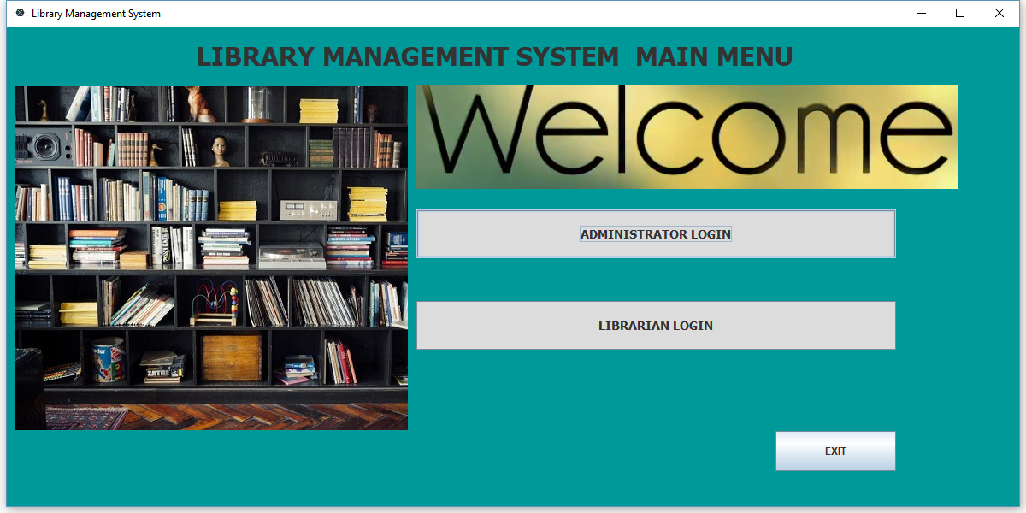

**Admin Login Page Interface:**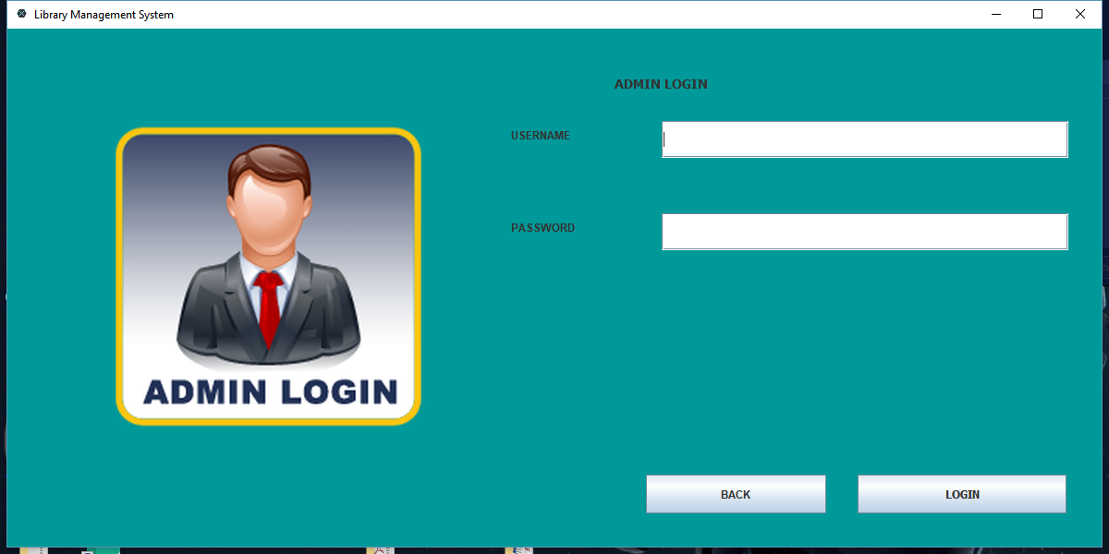

**Librarian Login Page Interface :**

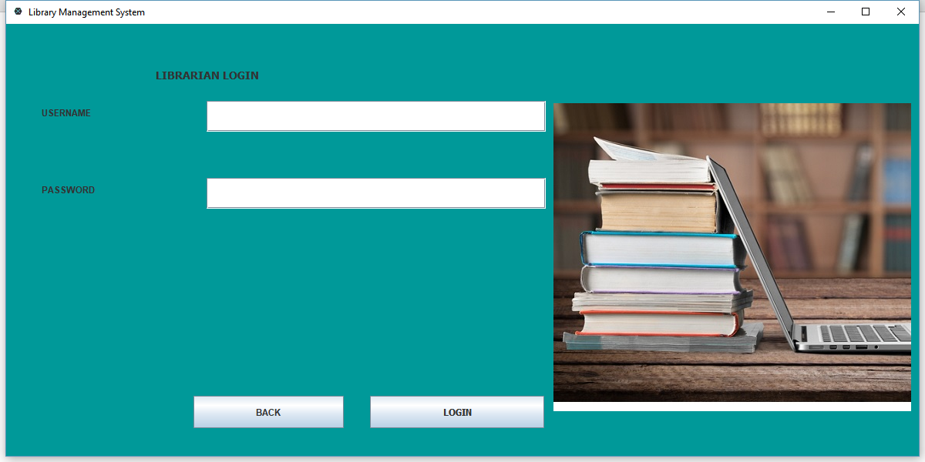

**Administrator main menu Interface:**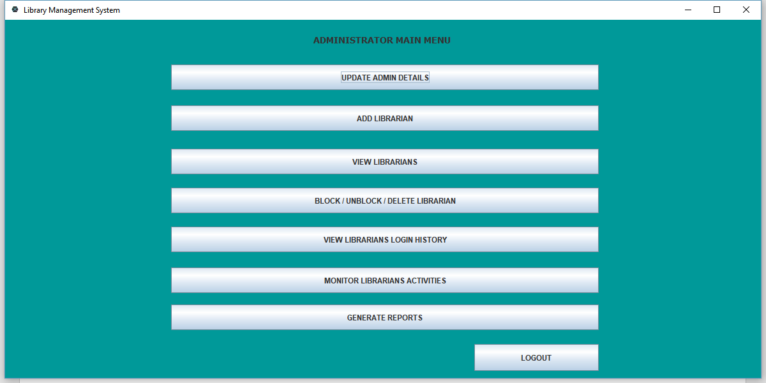

**Update admin details Interface:** 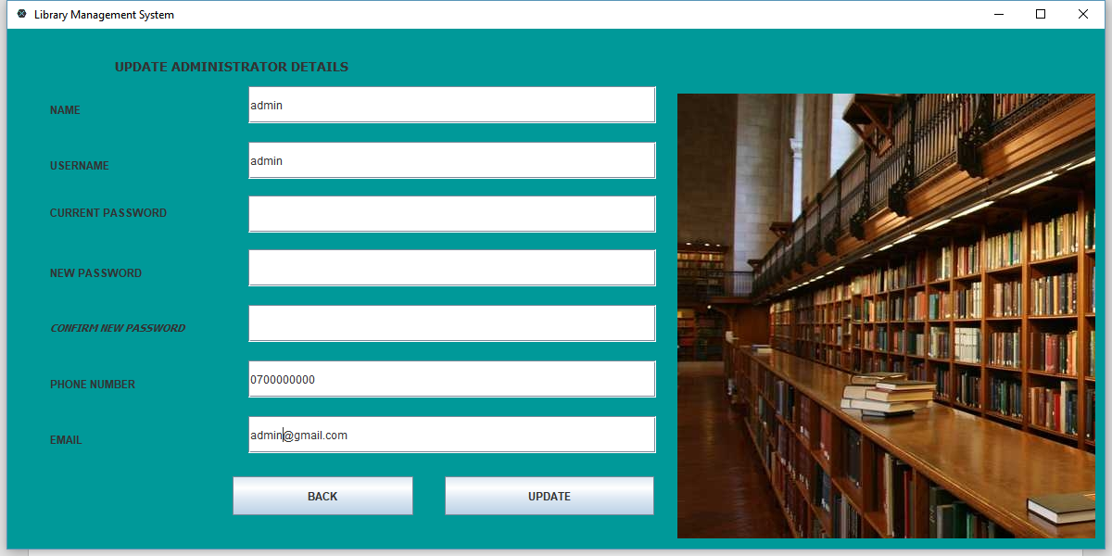

**Add librarian Interface:**

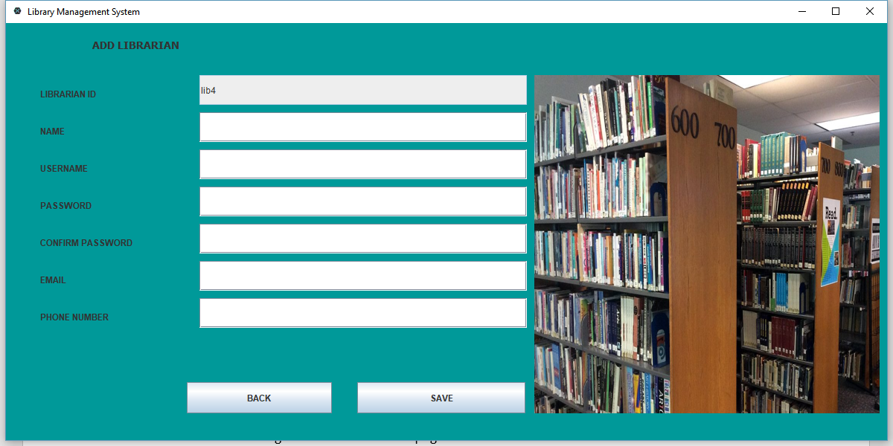

**View librarians Interface:**

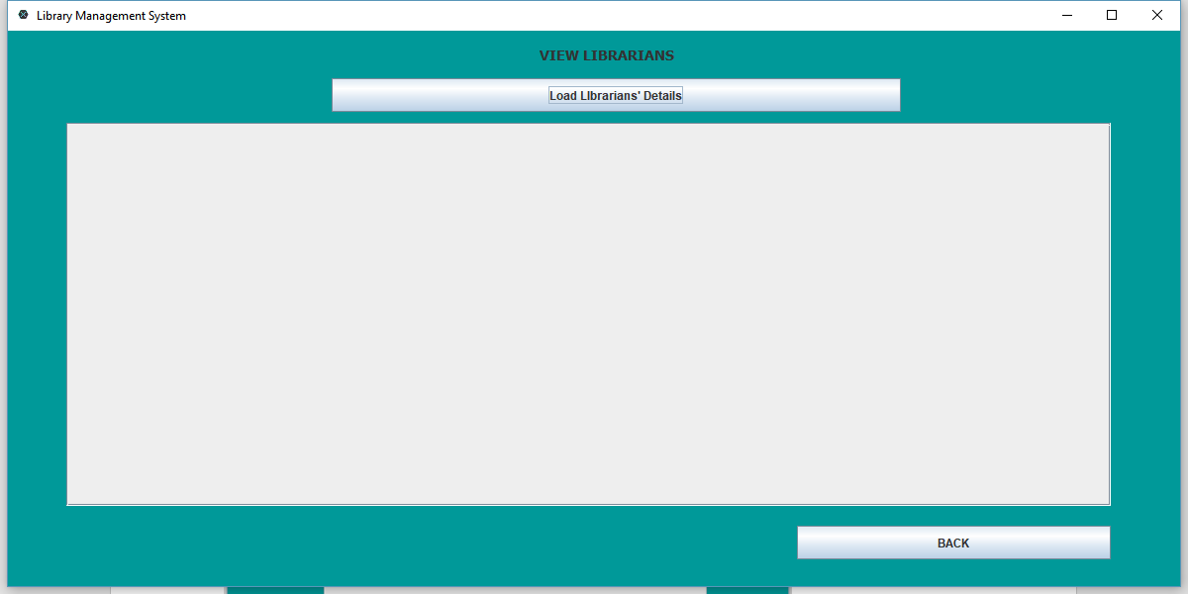

**Block / unblock / delete librarian Interface:**

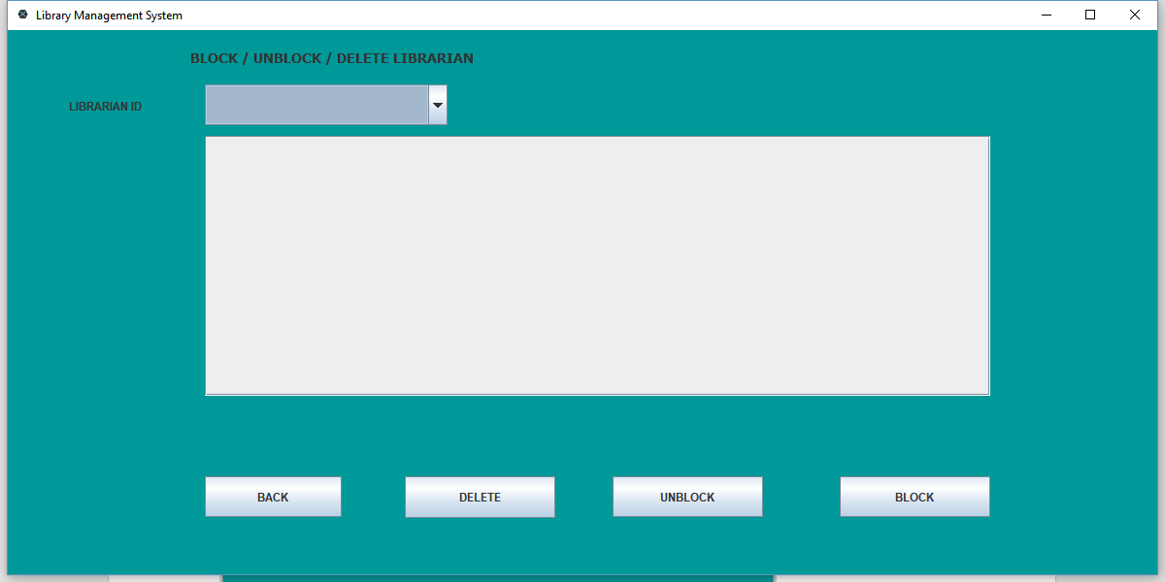

**View librarian login history Interface:**

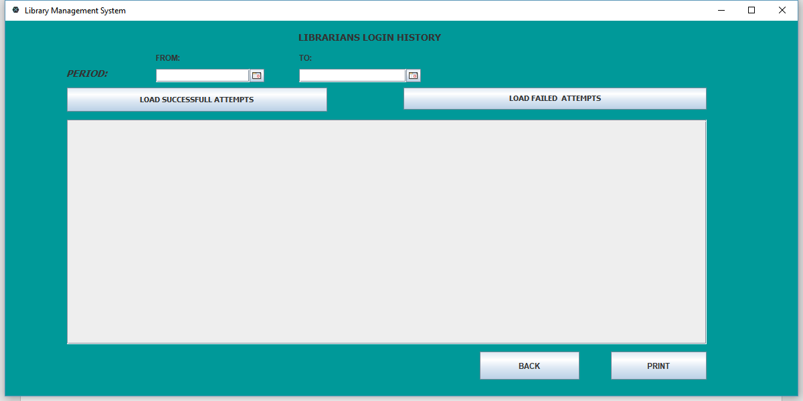

**Monitor librarian activities Interface:**

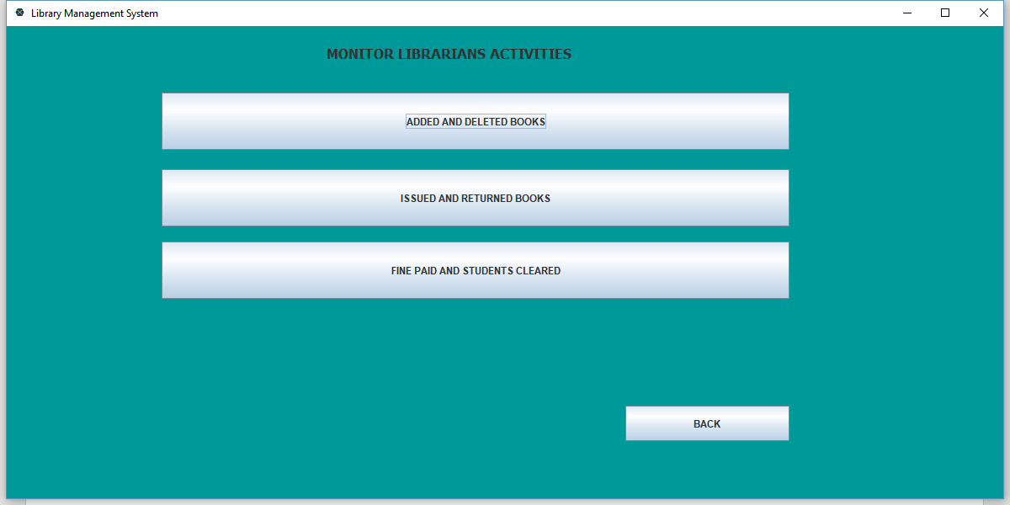

**Added and deleted books Interface:**

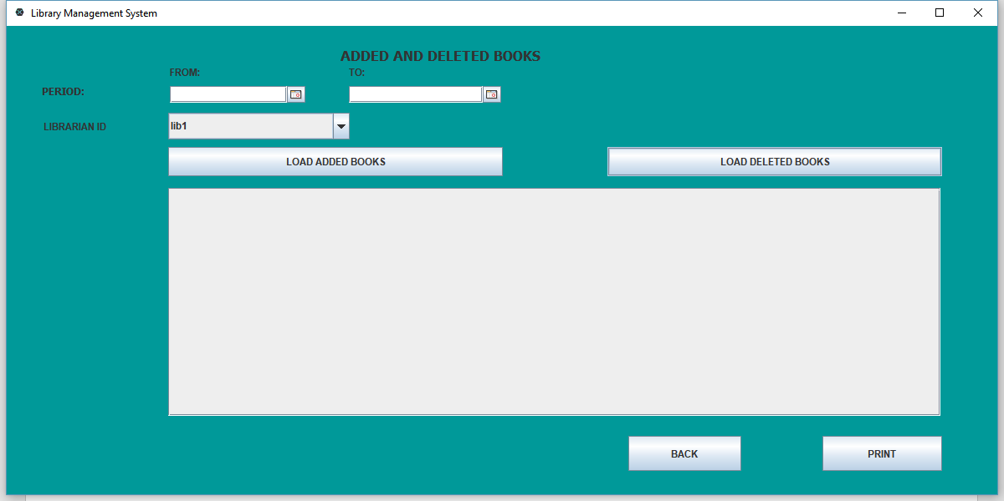

**Issued and returned books Interface:**

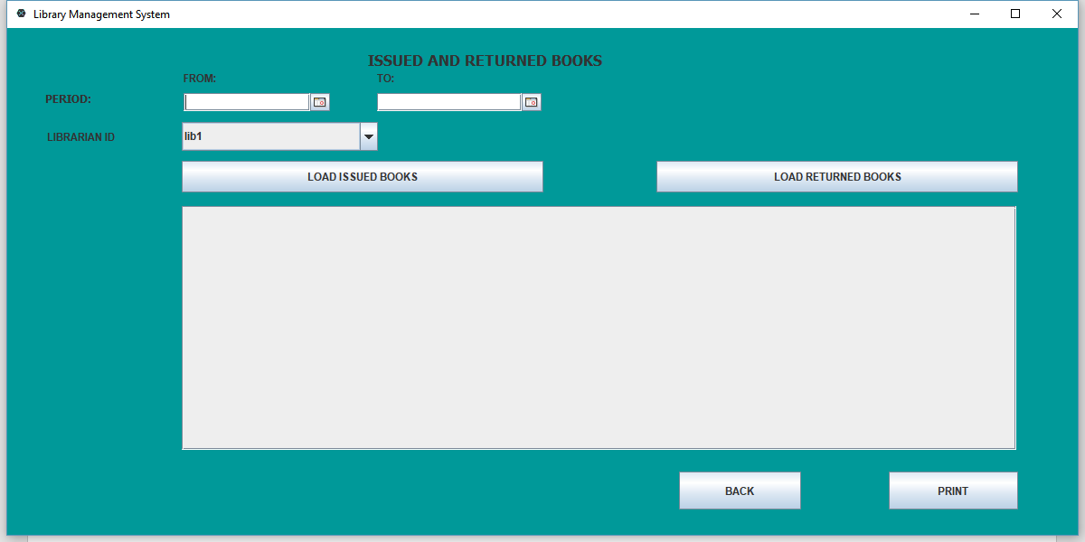

**Fines paid and students cleared Interface:**

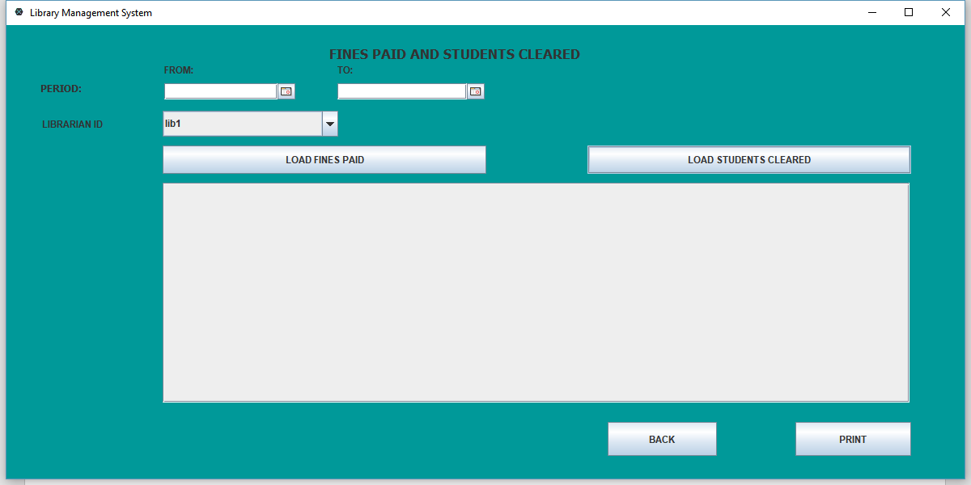

**Generate reports Interface:**

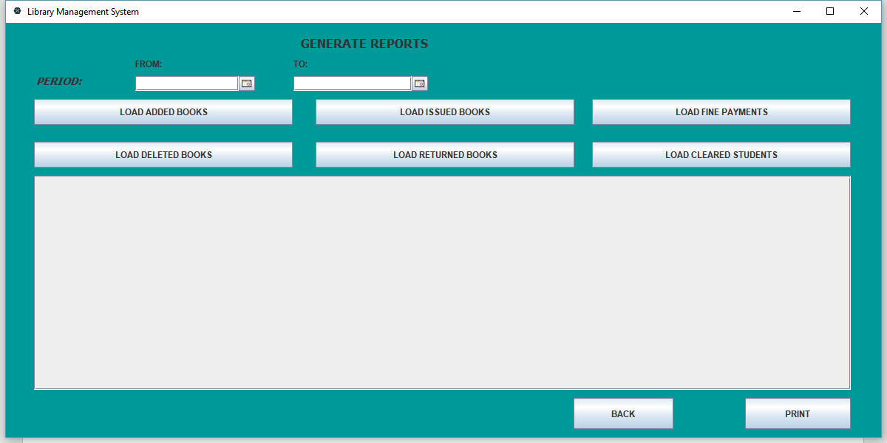

**Librarian main menu Interface:**

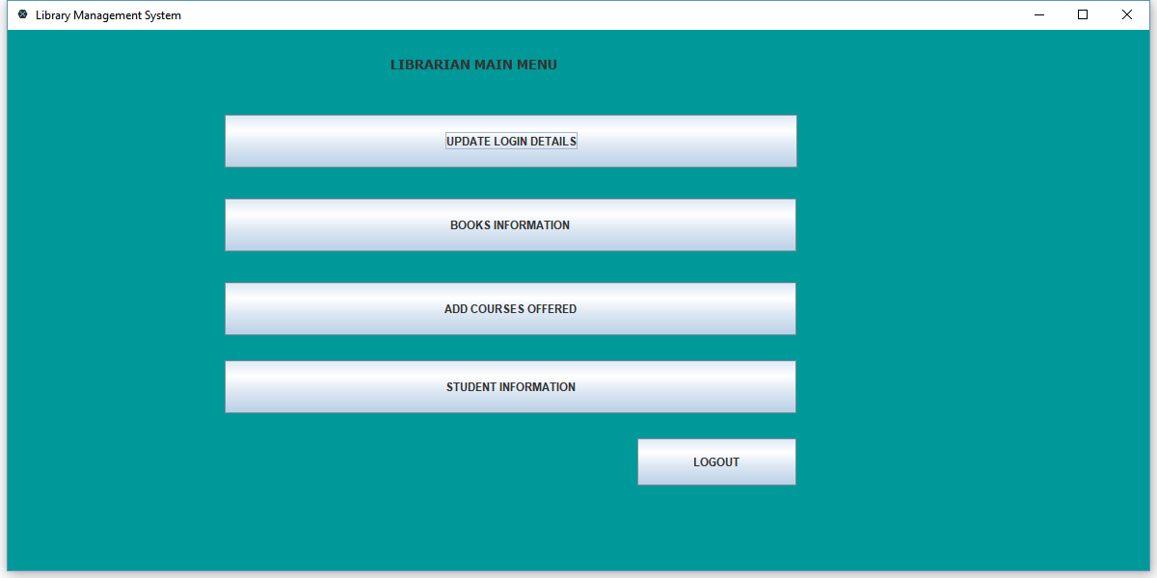

**Update librarian login details Interface:**

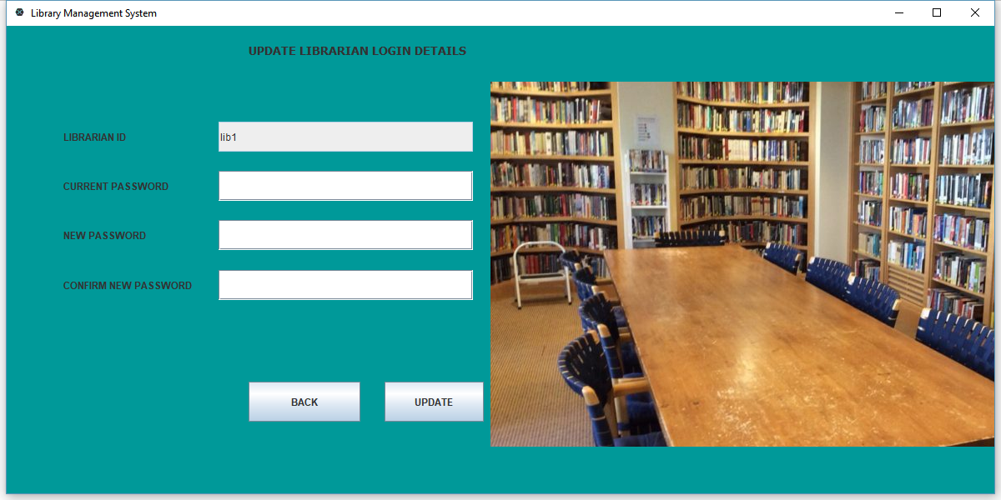

**Books information Interface:**

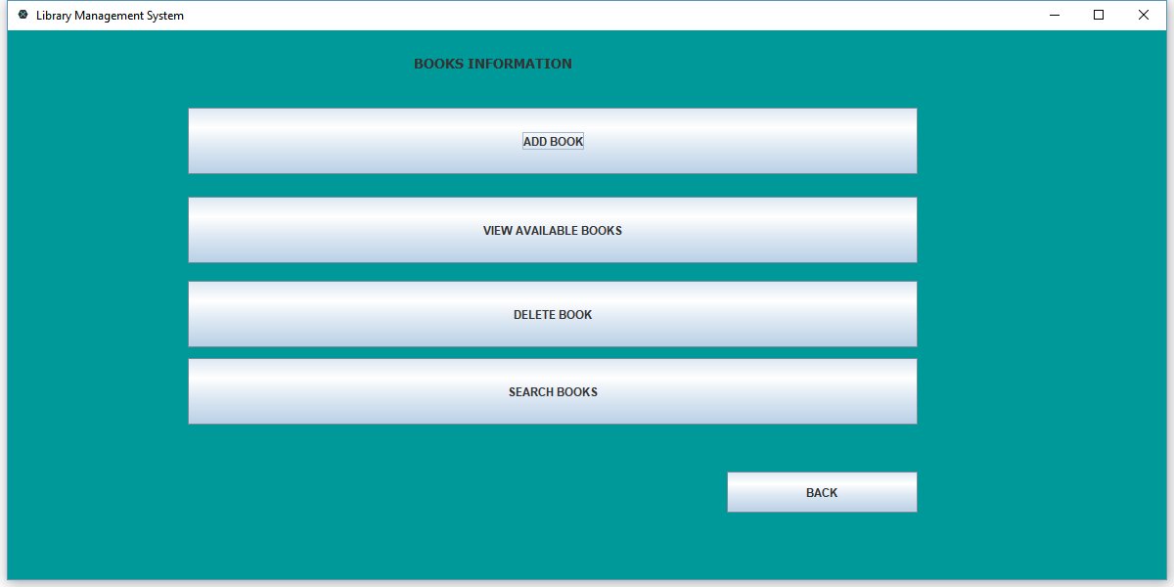

**Add books Interface:**

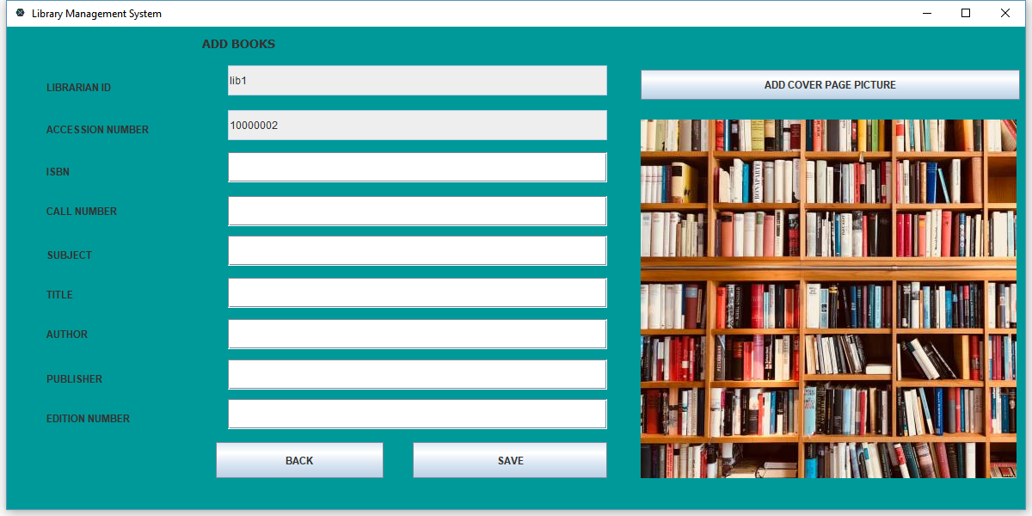

**View available books Interface:**

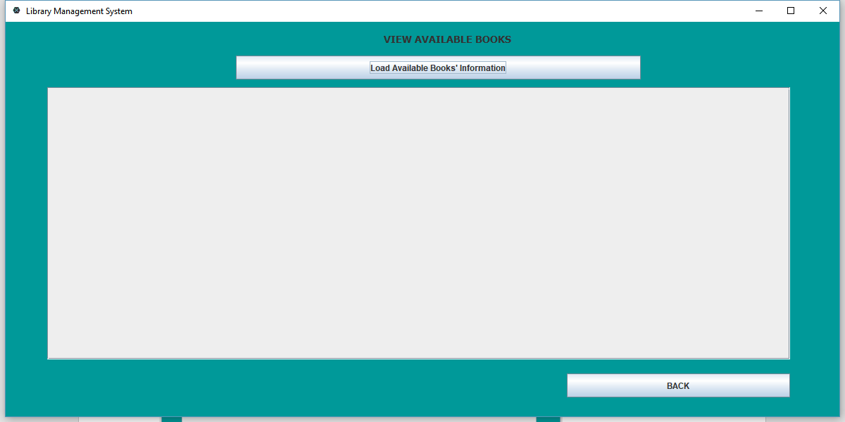

**Delete book Interface:**

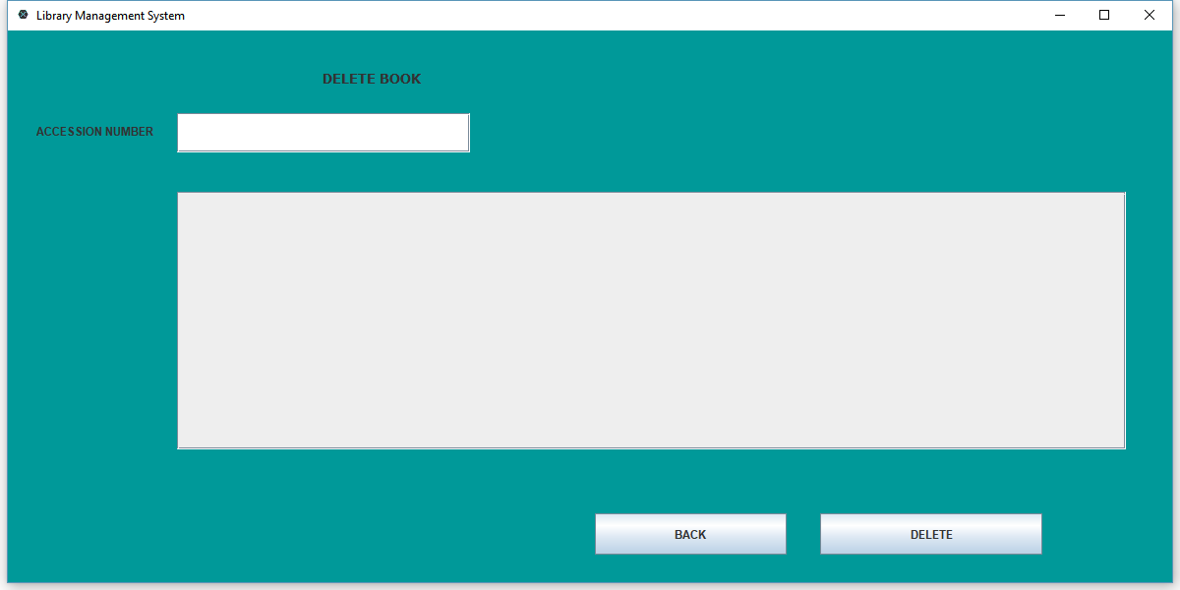

**Search books Interface:**

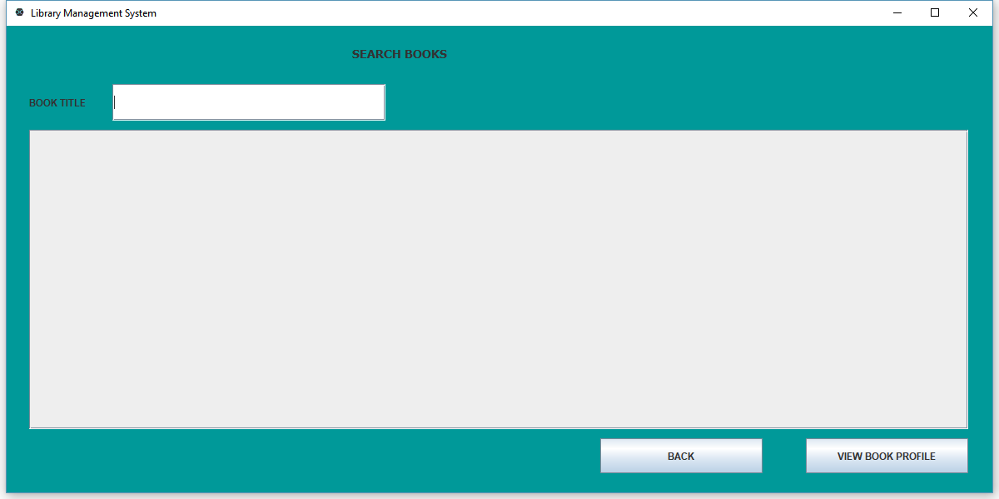

**Add courses offered Interface:**

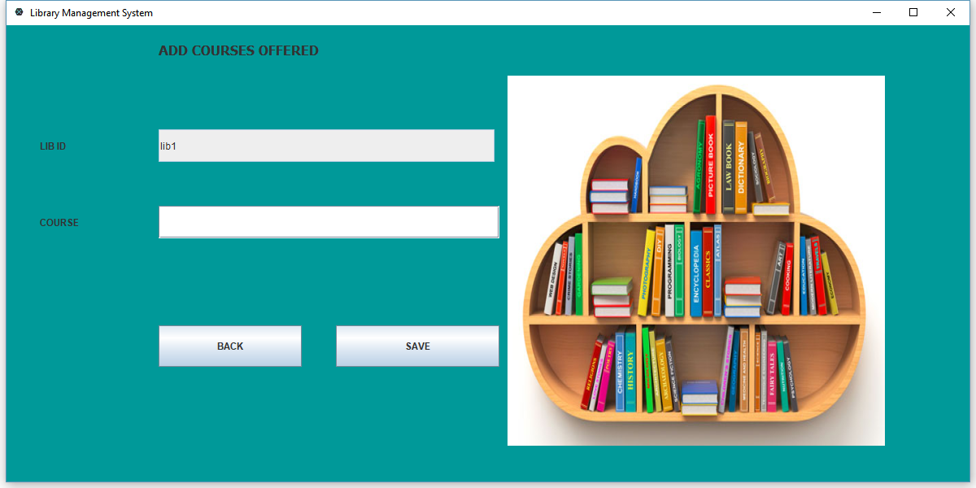

**Student information Interface:**

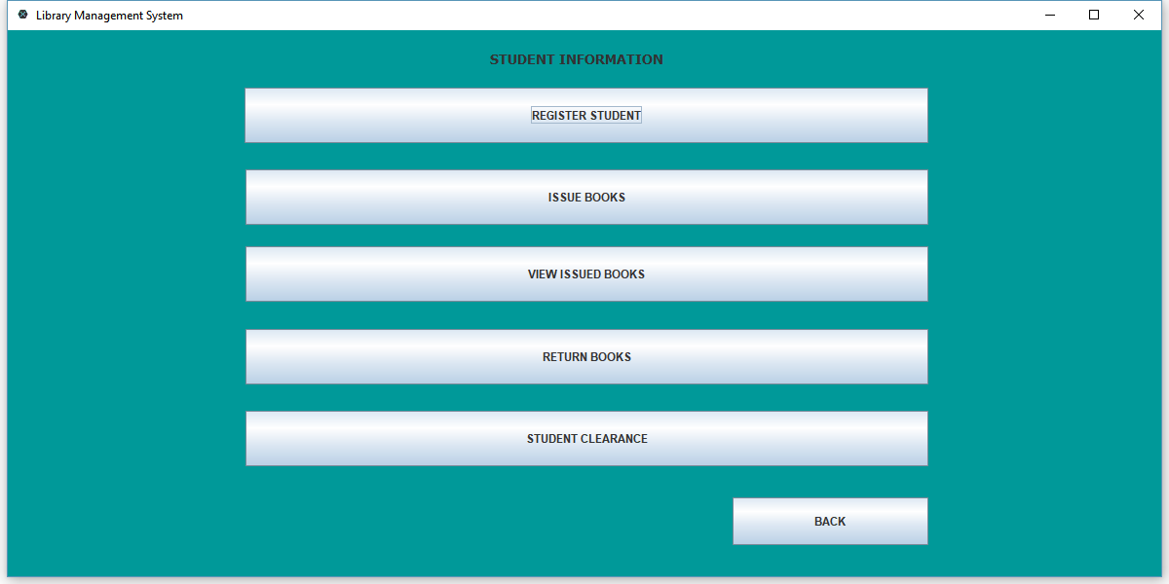

**Register student Interface:**

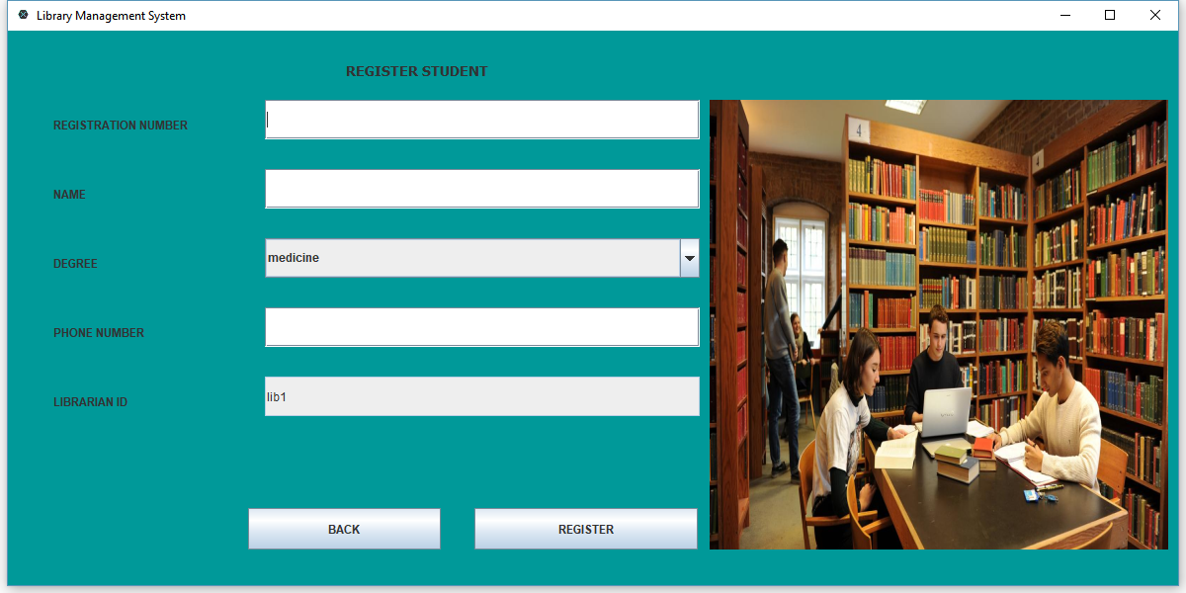

**Issue books Interface:**

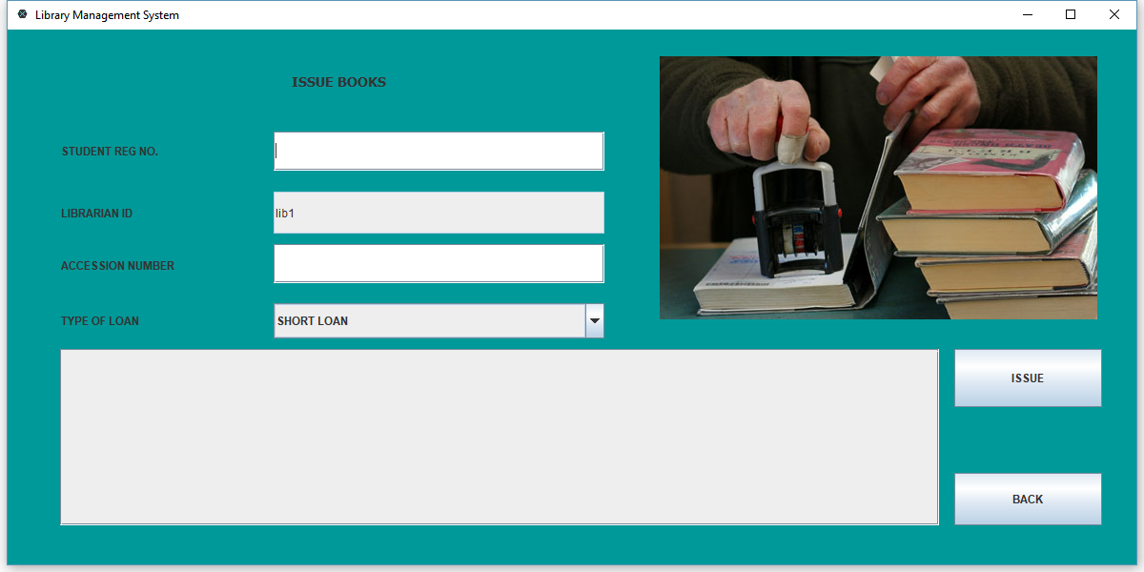

**View issued books Interface:**

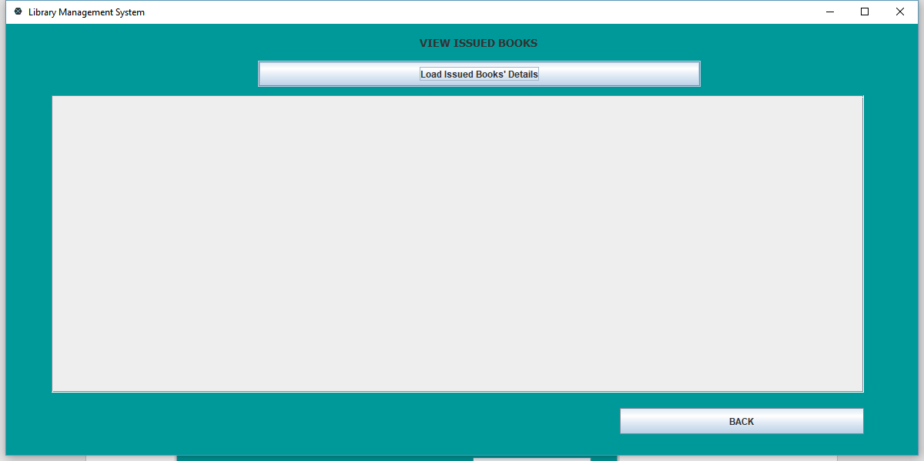

**Return books Interface:**

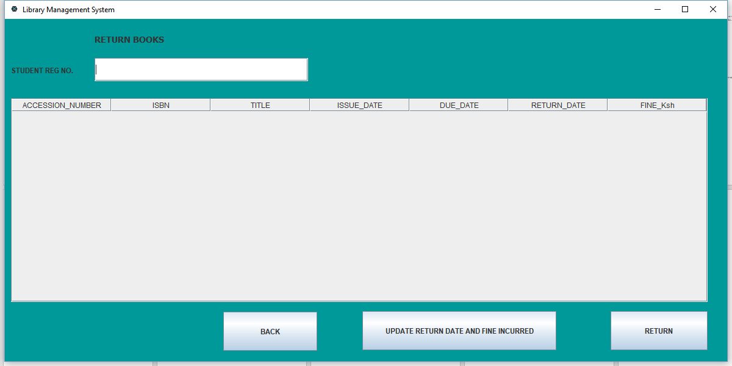

**Student clearance Interface:**

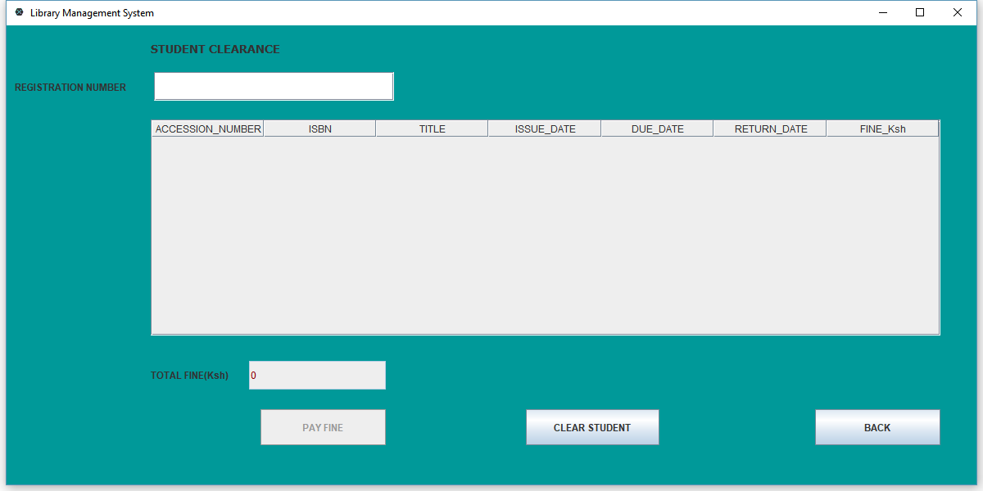

## 3.3 System Database/File Structure Preview:

The system’s database is made using a SQLite database management system. The structure of the database is as shown in the following screenshots;

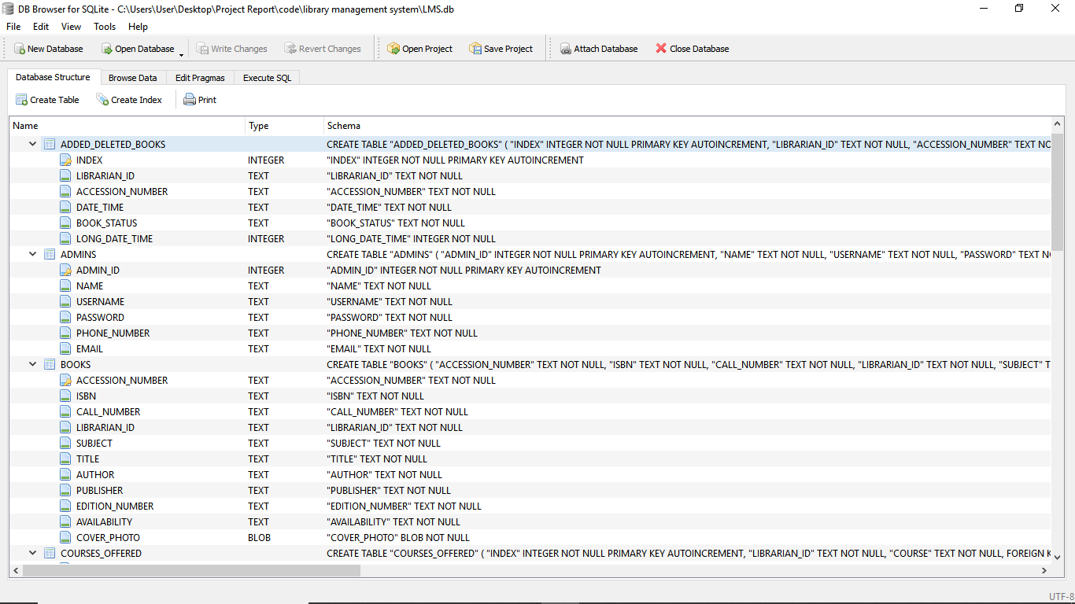

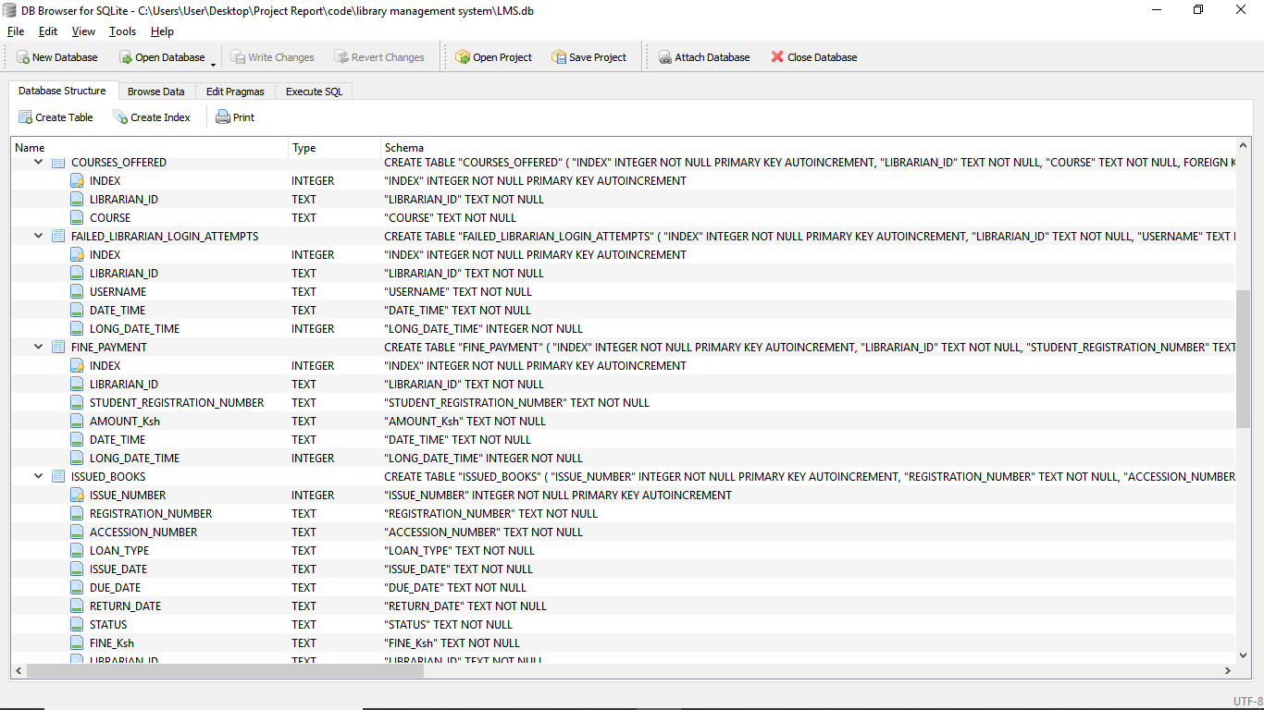

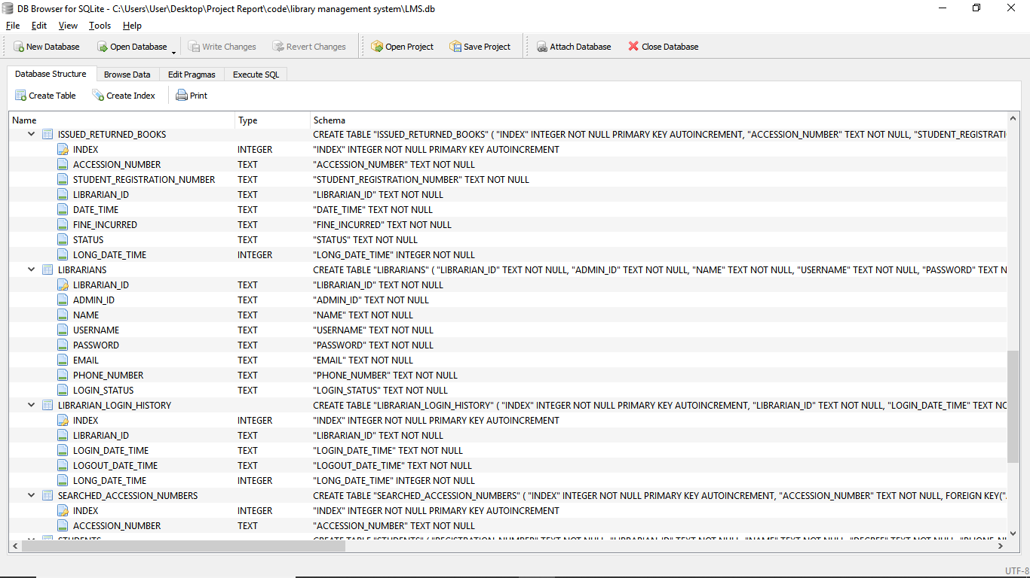

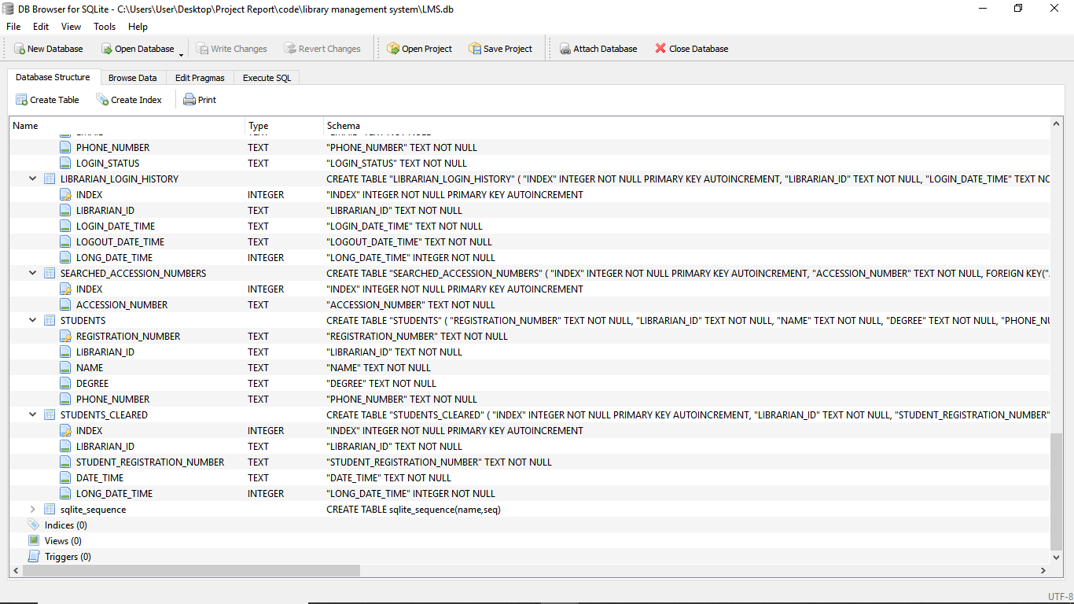

## 3.4 External and Internal Limitations and Restrictions:

**External limitations and restrictions;**

* The major external limitation of this system is that it does not support a client-server environment since it makes use of an embedded database.
* The application is standalone and hence doesn’t support multiple simultaneous log-ins.
* One also needs sufficient memory in their computers in-order for the application to be rendered smoothly on their devices.

**Internal limitations and restrictions;**

* The system provides access restrictions based on the user. So far, only the librarians and the administrator can access the system.
* The first restriction of the system is that a librarian cannot gain access to the system without first being registered/ signed up into the system by the administrator. They can only access the system after signing up for an account.
* The librarian cannot also access the system if their status is ‘BLOCKED’ and hence have to contact the administrator so as to be unblocked and be allowed access to the system.
* A librarian cannot register a student before adding the courses offered in the institution since student registration depends on the courses added for selecting the degree of study in the student registration form.
* A student cannot be issued with books if he/she is not yet registered by a librarian.

## 3.5 User Interface Specification:

### 3.5.1 User Screens/Dialog:

User screens for the application are designed in java swing. The application’s activities and fragments are properly linked to give the user a seamless execution of tasks.The following are the major dialogs in the application:

On successful login of the administrator/ librarians there is a welcome dialog as shown below:

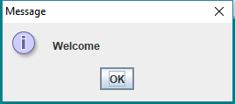

When updating administrator details the initial dialog is as shown below:

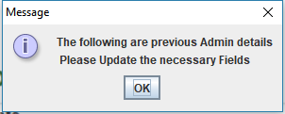

Before blocking a librarian, the following dialog is displayed:

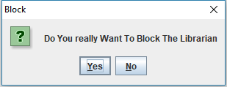

Before unblocking a librarian, the following dialog is displayed:

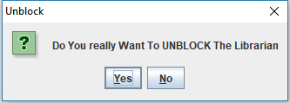

Before deleting a librarian, the following dialog is displayed:

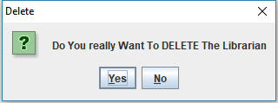

On using incorrect username and password for logging into the system, the following dialog is displayed:

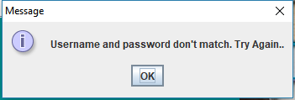

On providing an incorrect current password when updating login details, the following dialog is displayed:

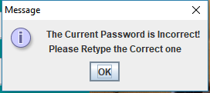

When adding a new copy of a book that already exists in the system, the following dialog is displayed:

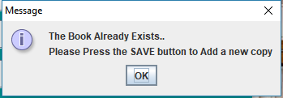

When deleting a book, the following dialog is displayed:

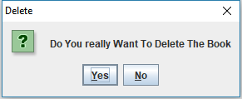

When issuing a book to a student that is not registered, the following dialog is displayed:

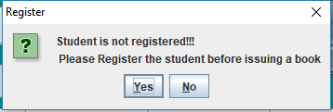

When returning a book, the following dialog is displayed:

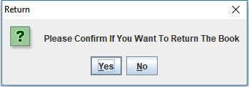

When clearing a student, the following dialog is displayed:

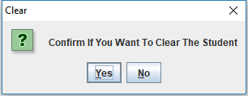

When clearing a student that has an unreturned book, the following dialog is displayed:

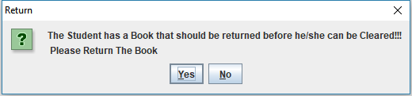

### 3.5.2 Report Formats/Sample Data:

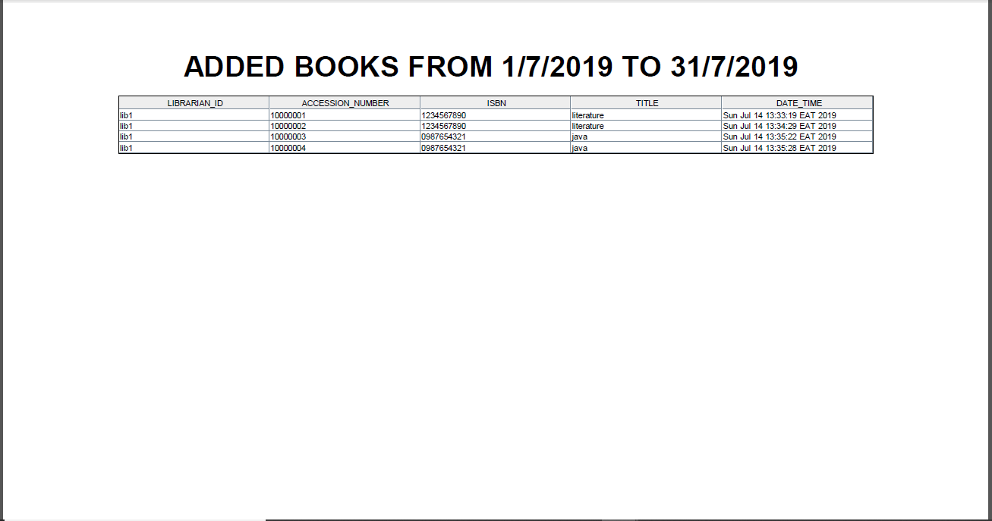

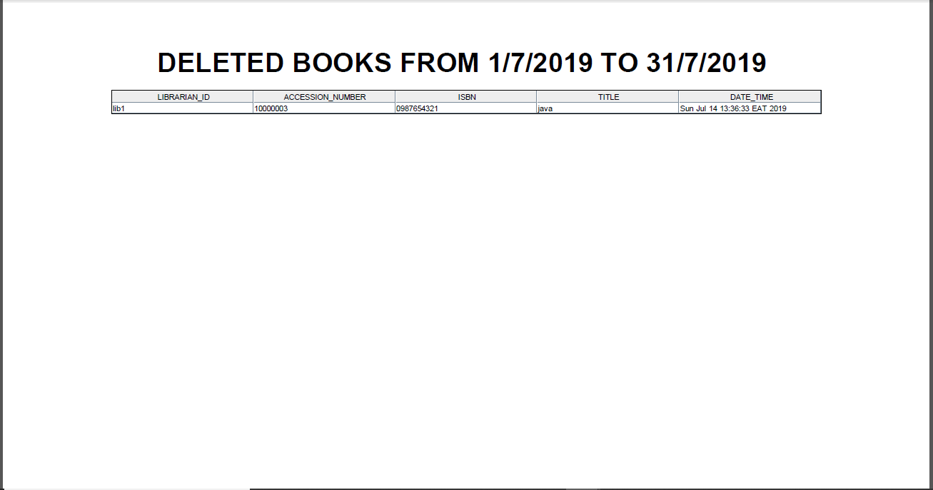

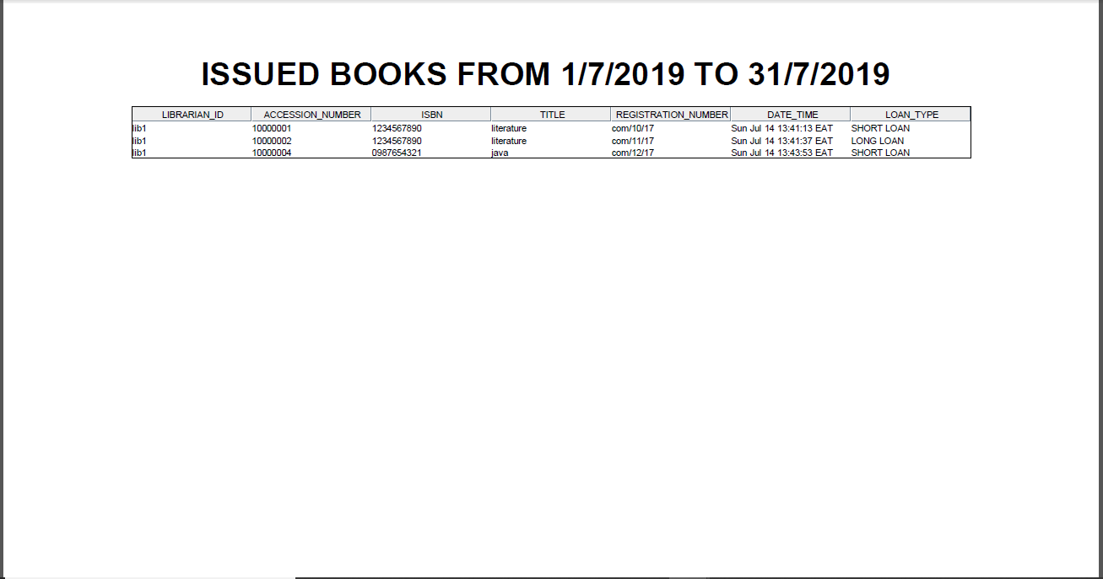

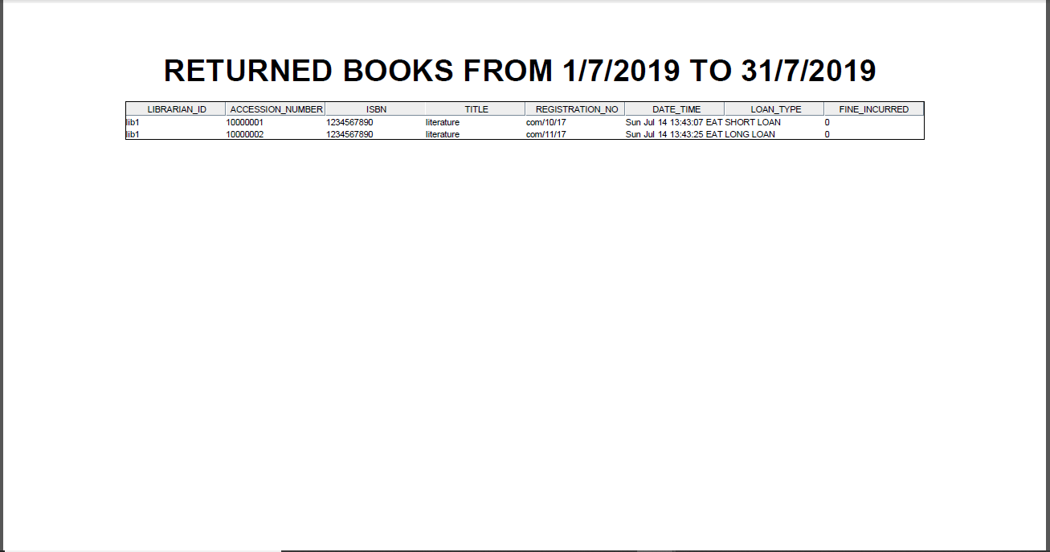

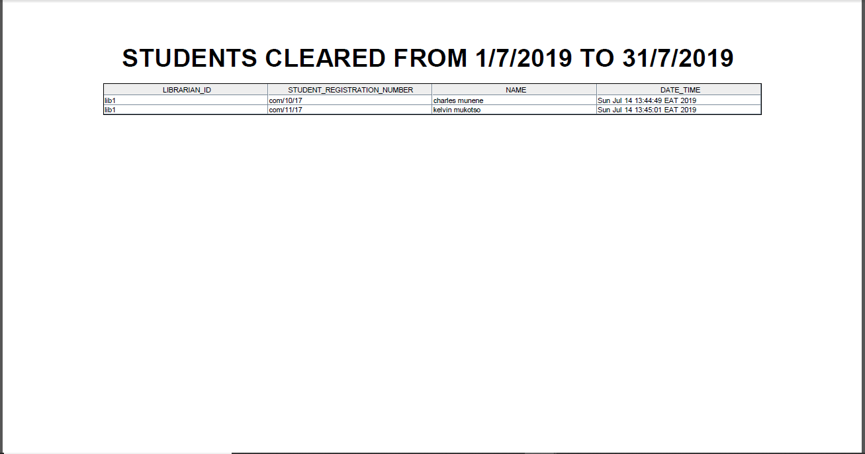

### 3.5.3 Error conditions and system messages:

Library management system is engineered in such a way that it offers informative error and system messages depending on the user’s operation. That is to say, it gives the user an interactive experience and the user is always informed of the status of the operations they are carrying out or that they intend to carry out. The following is a list of error conditions and their respective messages:

* Empty text-field.

This is a scenario whereby a user might try to perform an operation that requires them to fill specific information in text areas which they might forget or ignore. The system is designed to detect that specific area and remind the user to fill in, for instance, empty user-name.

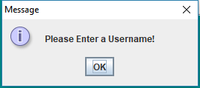

* Wrong credentials.

This is the case whereby a user tries to access system resources with wrong credentials. The system is designed in a way that the users are required to enter valid information for them to benefit from the system. A case in example is when a librarian tries to log in their accounts with wrong credential.

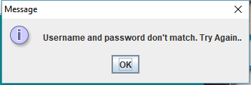

**System messages:**

* Successful operation

This are the messages displayed to the user after a successful operation. A user is notified with them when the operation they were performing has been completed successfully. For example, when the librarian adds a book to the system.

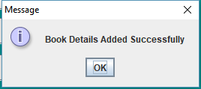

* When a book is deleted by a librarian:

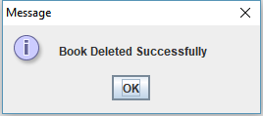

### 3.5.4 Control Functions:

The systems control functions depend on the module. For example, the librarian registration module provides control functions on the email format and password length. Control functions also provided on required fields to ensure that empty data is not submitted. Librarian login has control to ensure that only registered librarians are able to login and access system functionalities.

# 4. SYSTEM PERFORMANCE REQUIREMENTS

## 4.1 Efficiency

Efficiency of a system is a key non-functional requirement and describes the constraints placed on the system so that it can deliver its required functionalities to the user in a seamless manner, that is, efficiency describes the ease with which the system executes its operations. The Library Management system is an efficient system and the following are some of the parameters that can be used to depict the efficiency of the Library Management system.

**Speed**

The LMS is a real time system and its operations are automatic and executes immediately the user requests for them.

**Size**

The system is organized into two main operational modules for easy and efficient operation. These modules are: -

1. The main Logic Unit
2. The Database

The main logic unit is the module whereby all the system operational logic is made and is approximately 13MB.This is desirable for the system does not waste a lot of secondary memory unnecessarily.

The system database is the other interesting part of the LMS application. It is a dynamic database in that it does not have a fixed size, its size only increase when appropriate, that is, when the system requires more processing data and reduces appropriately when the system does not require data. Hence the system does not waste a lot of space in terms of database space unnecessarily. The database schema of the LMS is about 3MB which can increase progressively when the need arises.

**Peripheral devices usage**

The LMS is self-efficient in that it does not require in peripheral devices attached to it for it to function. As long as one has personal computer, they can log into the system and access all of its functionalities.

## 4.2 Reliability

### 4.2.1 Description of Reliability Measures

**Uptime** – For desktop application to be competitive and reliable, it needs to provide a high uptime. The LMS has not been left behind in providing a high level of up time. The development of the application ensured that it doesn’t crash, hence high reliability.

**Responsiveness** – The responsiveness of an application is key to supporting reliability. If an application is not responsive, then it is not reliable. The LMS application provides a high level of responsiveness during request of services. It is built on a user centered approach, thus removing unnecessary features that would make the application unresponsive.

**Accuracy** – If an application can accurately provide required services, then it is reliable. The LMS platforms provide a high accuracy levels.

**Consistency**- The platform provides high consistency levels both in the user interface and user inputs. This consistency ensures users develop quick familiarity with the system so as to solve problems more efficiently, thus maintaining reliability.

### 4.2.2 Error/Failure Detection and Recovery

Failure may occur during an application’s execution. Various methods have been implemented to ensure that in case of failure, users can report error occurrence or crash occurrence. User can however recover easily from errors.

### 4.2.3 Allowable/Acceptable Error/Failure Rate

The LMS is developed to experience little or no failure/error rate. If any, the errors levels acceptable are very low.

## 4.3 Security

### 4.3.1 Hardware Security

Hardware security is vulnerability protection that comes in the form of a physical device rather than software that is installed on the hardware of a computer system. Hardware security of the LMS can pertain to a device used to scan a system an examples include hardware security modules (HSM) Hardware systems can provide more robust security than software is capable of and can also add an additional layer of security for important systems.

The term hardware security also refers to the protection of physical systems from harm. Equipment destruction attacks. To assess the security of a hardware device, it’s necessary to consider vulnerabilities existing from its manufacture as well as other potential sources such as running code

In the case of more significant hardware and more critical function, the added reliability and lower number of vulnerabilities associated with hardware-based security may make it advisable. Critical infrastructure includes systems

### 4.3.2 Software Security

LMS authenticates users. User authentication ensures that the system prevents illegal access to information. The system also encrypts important data. Proper back end development was used to ensure that the system is free from attacks

### 4.3.3 Data Security

User data is protected from illegal access. Proper development methods are used to ensure data is free from attacks. All-important data are also encrypted to ensure they are not accessed illegally. This includes all user login passwords

### 4.3.4 Execution Security.

The data that users provide is checked to ensure that it is in the correct format. For example, users cannot provide emails in a format that is not of an email. Data is validated at user registration and login. Any data being sent to the database is validated to ensure it meets the systems minimum requirements.

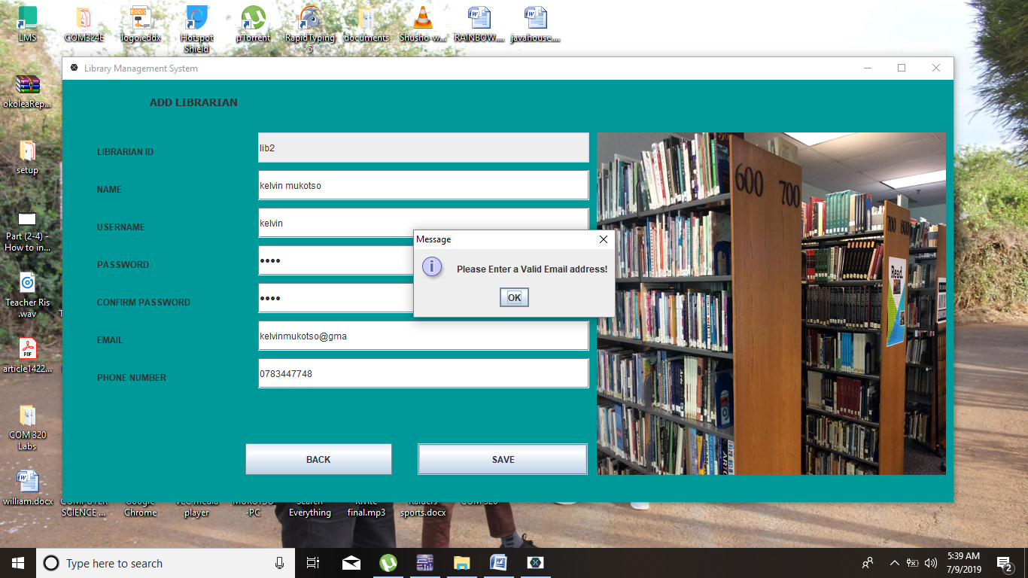

## 4.4 Maintainability

Maintainability describes the aspect of the system which describes how the system is designed to handle or how well the system is architecture to handle changes made to it. Maintainability of system is important because user requirements always keep changing and so the system might always be in constant up gradation. And also, in the cases whereby a bug is detected in the system’s functionality or operation, the system should be properly designed to allow for easy correction of the bugs without causing a glitch in the other system functionalities

Maintainability of the LMS supported. The structure of the systems source code is proper to ensure that in case of any repair, it can be carried out effectively. Development approaches common to every programmer have been used to ensure that the systems are maintainable.

## 4.5 Modifiability

The System is flexible therefore giving room to any modification in case new functionality is to be added to it. Any change can be done on the system.

## 4.6 Portability

This is the property of the system to be able to work under various different environments. A portable system is one in which it can be installed or rather one that can operate of different platforms. The LMS is portable software in the different ways as follows.

The business logic of the LMS is developed using Java programming language. The advantage of using java for the development is that Java is a cross platform programming language meaning that the system can be installed and run on different operating systems like:

* Windows Operating System
* Unix/Linux Environment and Macintosh Operating system

# 5. SYSTEM DESIGN OVERVIEW

## 5.1 System Data Flow Diagrams

**Context Diagram:**

Administrator

Librarian

**Logical Data Flow Diagram:**

Books information

Student information

Add courses

Librarian

Block/unblock/delete librarian

Update login details

View librarian login history

Generate reports

Add librarian

Update login details

View librarians

Monitor librarians

Administrator

## 5.2 System architecture and structure

LMS

Librarian login

Admin login

Update details

Block/unblock/delete librariam

Add librarian

Update details

Add courses offered

View librarian login history

Student information

Books information

View librarians

Monitor librarian activities

Generate reports

## 5.3 System Data Dictionary

|  |  |  |  |  |  |  |
| --- | --- | --- | --- | --- | --- | --- |
| **Table Name** | **Column Name** | **Data type** | **Size** | **Null** | **Key(PK/FK)** | **Description** |
| ADDED_DELETED BOOKS | INDEX | INTEGER | 255 | No | Primary | index for books. It is auto incremented |
| LIBRARIAN_ID | TEXT | 255 | No | Foreign | Is a unique ID that identifies each librarian |
| ACCESSION_NUMBER | TEXT | 255 | No |  | It is a unique number for each book. |
| DATE_TIME | TEXT | 255 | No |  | It is the date and time the book was deleted. |
| BOOK_STATUS | TEXT | 255 | No |  | It gives status of each book. |
| ADMINS | ADMIN_ID | INTEGER | 255 | No | Primary | A unique Id for the administrator |
| NAME | TEXT | 255 | No |  | Is the name of the admin |
| USERNAME | TEXT | 255 | No |  | It is the username of admin. |
| PASSWORD | TEXT | 255 | No |  | It is the password of admin. |
| PHONE_NUMBER | TEXT | 255 | No |  | It is the phone number of admin. |
| EMAIL | TEXT | 255 | No |  | It is the email of admin. |
| BOOKS | ACCESSION_NUMBER | TEXT | 255 | No | Primary | A unique number for each book. It is auto incremented |
| ISBN | TEXT | 255 | No |  | Is a number that identifies same copies of books |
| CALL_NUMBER | TEXT | 255 | No |  | It is the number assigned to a book by librarian. |
| LIBRARIAN_ID | TEXT | 255 | No | Foreign | It is a unique id for each librarian. |
| SUBJECT | TEXT | 255 | No |  | It is the subject of a book. |
| TITLE | TEXT | 255 | No |  | It is the title of a book. |
|  | AUTHOR | TEXT | 255 | no |  | It is the author of a book |
|  | PUBLISHER | TEXT | 255 | no |  | It is the name of publisher of a book |
|  | EDITION_NUMBER | TEXT | 255 | no |  | Is the edition number of a book |
|  | AVAILABILITY | TEXT | 255 | no |  | It is the status of a book |
|  | COVER_PHOTO | BLOB | 255 | no |  | Is the cover picture of a book |
| COURSES_OFFERED | INDEX | INTEGER | 255 | No | Primary | Index of the courses. It is auto incremented |
| LIBRARIAN_ID | TEXT | 255 | No | Foreign | Is a unique ID that identifies the librarian who added the course |
| COURSE | TEXT | 255 | No |  | It is the name of each course. |
| FAILED_LIBRARIAN_LOGIN_ATTEMPTS | INDEX | INTEGER | 255 | No | Primary | Index for failed logins. It is auto incremented |
| LIBRARIAN_ID | TEXT | 255 | No | Foreign | Identifies the ID of librarian that failed to login |
| USERNAME | TEXT | 255 | No |  | It is the username of the librarian who failed to login successfully. |
| DATE_TIME | TEXT | 255 | No |  | It is the date and time the failed login was made |
| FINE_PAYMENT | INDEX | INTEGER | 255 | No | Primary | Index for users. It is auto incremented |
| LIBRARIAN_ID | TEXT | 255 | No | Foreign | Identifies the ID of librarian who received the payment |
| STUDENT_REGISTRATION_NUMBER | TEXT | 255 | No |  | It is the registration number that paid fine |
| AMOUNT_Ksh | TEXT | 255 | No |  | It is the amount of fine that was paid. |
| DATE_TIME | TEXT | 255 | No |  | It is the date and time payment was made. |
| ISSUED_BOOKS | ISSUE_NUMBER | INTEGER | 255 | No | Primary | Is the issue number for books. It is auto incremented |
| REGISTRATION_NUMBER | TEXT | 255 | No | Foreign | Is the registration number of student issued with a book |
| ACCESSION_NUMBER | TEXT | 255 | No | Foreign | It is the unique number for each issued book. |
| LOAN_TYPE | TEXT | 255 | No |  | It is the type of loan of an issued book. |
| ISSUE_DATE | TEXT | 255 | No |  | It is the date a book was issued. |
| DUE_DATE | TEXT | 255 | No |  | It is the date a book is due. |
|  | RETURN_DATE | TEXT | 255 | No |  | It is the date the book is to be returned |
|  | STATUS | TEXT | 255 | No |  | The status of a book |
|  | FINE_Ksh | TEXT | 255 | no |  | Amount of fine |
|  | LIBRARIAN_ID | TEXT | 255 | No |  | Is an id for each librarian that issued the book |
| ISSUED_RETURNED_BOOKS | INDEX | INTEGER | 255 | No | Primary | index for an issued and returned book. It is auto incremented |
| ACCESSION_NUMBER | TEXT | 255 | No | Foreign | Is a unique number that identifies each book issued and returned |
| STUDENT_REGISTRATION_NUMBER | TEXT | 255 | No | Foreign | It is the unique number of each student. |
| LIBRARIAN_ID | TEXT | 255 | No | Foreign | It is the unique id for each librarian. |
| DATE_TIME | TEXT | 255 | No |  | It is the date and time. |
| FINE_INCURRED | TEXT | 255 | No |  | It is the fine to be paid. |
| STATUS | TEXT | 255 | no |  | The status of a book |
| **Table Name** | **Column Name** | **Data type** | **Size** | **Null** | **Key(PK/FK)** | **Description** |
| LIBRARIANS | LIBRARIAN_ID | TEXT | 255 | No | Primary | Unique id for each librarian. It is auto incremented |
| ADMIN_ID | TEXT | 255 | No | Foreign | Is a unique ID that identifies the admin who added the librarian |
| NAME | TEXT | 255 | No |  | It is the name of each librarian. |
| USERNAME | TEXT | 255 | No |  | It is the username of each librarian. |
| PASSWORD | TEXT | 255 | No |  | It is the password of a librarian. |
| EMAIL | TEXT | 255 | No |  | It is the email of a librarian. |
|  | PHONE_NUMBER | TEXT | 255 | No |  | The telephone number of a librarian |
|  | LOGIN_STATUS | TEXT | 255 | No |  | The login status of a librarian |
| LIBRARIAN_LOGIN_HISTORY | INDEX | INTEGER | 255 | No | Primary | index for the librarian login history. It auto incremented |
| LIBRARIAN_ID | TEXT | 255 | No | Foreign | Is a unique ID that identifies each librarian in the system |
| LOGIN_DATE_TIME | TEXT | 255 | No |  | It is the date and time of login. |
| LOGOUT_DATE_TIME | TEXT | 255 | No |  | It is the date and time of logout. |
| SEARCHED_ACCESSION_NUMBER | INDEX | INTEGER | 255 | No | Primary | Index for searched accession number. It is auto incremented |
| ACCESSION_NUMBER | TEXT | 255 | no | Foreign | Is a unique number that identifies each book searched |
| STUDENTS | REGISTRATION_NUMBER | TEXT | 255 | No | Primary | Unique number for students. |
| LIBRARIAN_ID | TEXT | 255 | No | Foreign | Is a unique ID that identifies each librarian that added student |
| NAME | TEXT | 255 | No |  | It is the name of each student registered. |
| DEGREE | TEXT | 255 | No |  | It is the course of a student. |
| PHONE_NUMBER | TEXT | 255 | No |  | It is the phone number of each student. |
| STUDENTS_CLEARED | INDEX | INTEGER | 255 | No | Primary | index for cleared students. It is auto incremented |
| LIBRARIAN_ID | TEXT | 255 | No | Foreign | Is the ID of librarian that cleared student |
| STUDENT_REGISTRATION_NUMBER | TEXT | 255 | No | Foreign | It is the unique number of each student. |
| DATE_TIME | TEXT | 255 | No |  | It is the date and time. |

## 5.4 Description of System Operation.

The LMS system is a java application. The application is tailored for use by the administrator and the librarian.

It operates by providing the librarian an easy way of managing books in the library. An active librarian is able to add books in the system, view books, issue them to students and clear students once they return a book. A librarian can as well search for a book to know its status and if it is available for issuing.

The application enables the administrator to monitor the activities of the librarians. Based on their activities the administrator can choose to block or delete a librarian. The administrator has the role of registering a new librarian into the system. He also has the privilege of generating reports based on certain periods which assists in the monitoring of the different activities of the librarians and running of the library as a whole.

This system therefore ensures an easy and smooth way of running the day to day activities of a library.

## 5.6 Implementation Languages

The system has been developed using Java programming language. Java, as a programming language, offers several benefits. The first and foremost is that the application can be run on any Operating System that has the Java Runtime Environment installed (JRE). This allows the application, once compiled, be executed on Linux, Windows and Mac OS.

Another reason is the extensive support for Object Oriented Programming. Java is Object Oriented, which enables the design of robust applications.

Java has a large ecosystem and has been around for over two decades. There is a huge set of libraries that allow rapid development of software. In addition, there are several frameworks, tools and a large supportive community that make software development in Java productive.

Java is statically typed, making many errors easy to spot at compile time.

Java also has powerful development tools. Eclipse and Netbeans have played a huge role to make Java one of the best programming languages. They help in code completion and provide a powerful debugging capability.

Java is easy to learn. Java has fluent English like syntax with minimum magic characteristics which makes it easy to learn. Once a programmer is familiar with initial hurdles with installing JDK and setting up PATH and understand how Classpath works, it is easy to write program in Java.

Lastly, Java has a rich API. Java provides API for I/O, networking, utilities and even database connection.

## 5.7 Required Support Software (Pre-Existing)

For LMS to work, the following software needs to exist first.

* Java Runtime Environment

The Java Runtime Environment needs to exist first since LMS is developed in Java.

# 6. SYSTEM DATA STRUCTURE SPECIFICATION

The LMS is a system that takes input data from two categories of users and performs the required operations on the data and then displays the required output data to the users. It is therefore an interactive system that users constantly interact with it to get their desired output data.

## 6.1 User Input specification

### 6.1.1 Identification of user input data.

The LMS basically processes data from its users to perform the required operations on the user’s data. The following is the list of the user input data.

1. Personal information data

This is the data that the users provide to the system the first time they sign up for an account in the system. This data includes their official names, passwords and contact information. This is the data that is used by the system to identify and authenticate the user of the system.

1. Authentication data

This data entails the user’s username and password which they must provide to the system before they can be given access to the system. The username and password must be unique and specific to a specific user without which they will not be validated to access the system.

1. Book data

This is the data provided by the librarian when adding a new book to the system. It usually includes the accession number which is auto-generated by the system. Others include the book isbn, call number, title, subject, author, publisher and edition number.

1. Student data

This entails student’s information like their names and registration number.

### 6.1.2. Sources of input data (Not Input devices)

There are different categories or sources of input data to the system. The various types of data originate from the following groups of users.

1. **Administrator**

This is the group of the systems users that perform much of the interaction with the system. It is the group that registers and manages the librarians in the system. The input data that they provide includes their personal information and authentication data.

1. **Librarian**

The librarian is another important source of the input data to the LMS system. The librarian is the user who is responsible for adding books to the system, registering students, issuing registered students with books and clearing students once they return borrowed books.

### 6.1.3. Input medium and/or Devices

In an effort to maintain the simplicity of the application, the LMS has two major input devices as mentioned below.

1. **The Keyboard**

This is used by the users to type into the system input data so that it can be processed by the system

1. **The Mouse**

The mouse is basically used to navigate through the system as the user is entering data using the keyboard. The mouse is also used to click to submit or change the presentation of the input data while the user is entering the data.

### 6.1.4. Data format/Syntax.

The system is designed to process data in the following formats.

1. **Textual format.**

This is data inform of normal English word, texts and sentences. Words are typed into the system using the keyboard to be utilized later by the users.

1. **Numbers format**

This is input inform of numbers that is entered into the system for the system to process and present the appropriate output data. Such data includes book isbn number.

1. **Pictorial format**

This is data inform of pictures that is entered into the system. Example of such data would include the cover page of each book that is added to the system.

## 6.2 User output Specification

### 6.2.1 Identification of output data

The output data is more or less identified in the same way that the input data is identified. The output data includes the following types of data.

1. Personal information

This is presented to the user when they wish to update their details. Their personal information is presented to them and they are also given a mechanism by which they can modify the data if the need arises.

1. Book search results

When the librarian searches a certain book, all the books details are shown including its status, that is, if it is available, issued or deleted.

1. View books

This is presented when a librarian wants to view the books that are available for issuing to students. The books’ information is provided as well.

1. Generate reports

This is presented when an administrator wants to produce reports on various librarian activities undertaken in the system

### 6.2.2 Output Medium and/or device.

The output medium for the application is the monitor for users who use the computer to access the applications functionality.

The output medium for the generated reports is the printer

### 6.2.3 Output format/Syntax

The output format for LMS data is in various forms as mentioned below: -

1. **Alphanumerical data**

This is the data presented to the various users as textual and numerical output. The users can then easily read, understand and interpret that data.

1. **Pictorial Data**

This is data inform of pictures that is presented to the user as output once a given operation has been finished. Example is the cover pictures presented to the user once they search and the search results are presented to them.

### 6.2.4 Output Interpretation

**Search results**

Librarian search results for a book is one of the outputs the system displays. The information displayed include;

* A book’s cover page
* The book’s details like the Author’s name, publisher, title and edition number.

## 6.3 system database /file structure specification

### 6.3.1 Identification of Data Base/Files

The LMS system data is stored in a single SQLite database. The database is made up of thirteen tables which are the books, courses-offered, failed-librarian-login-attempts, admins, librarians, fine-payment, issued-books, issued-returned-books, librarian-login-history, searched-accession-numbers, added-deleted-books, students and students-cleared.

The books table stores records of the books in the system. The courses-offered table stores records of the courses available, the failed-librarian-login-attempts table stores all failed logins made by the librarians, the admins table stores the administrator details, the librarians table stores the librarians’ details, the issued-returned-books table stores all the books that have been issued and returned. The librarian-login-history table stores the login history of librarians.

### 6.3.2 Subsystems Accessing the Database

The two subsystems (the Administrator and Librarian) access the database. The following is a listing and a discussion of the operation done on the database.

* **The administrator subsystem** stores a librarian’s personal information into the database during registration of a librarian.
* **The two subsystems** query the database when a user attempts to log in order to compare the supplied credentials with those in the database.
* **The administrator subsystem** reads information from the database when generating reports.
* **The librarian subsystem** read data from the database each time he/she views books in the system.
* **Both subsystems** update data in the database when the administrator or librarian updates his/her details.

### 6.3.3 Logical File Structure

Data is stored in form of row and columns in SQLite database. The structure of data depends on the conventions provided by SQLite database management systems.

### 6.3.4 Physical File Structure

So far, the LMS system does not support physical storage of data. All data used in the system is stored in the database and accessed from the database by the administrator and librarian.

### 6.3.5 Data Base Management Subsystems Used (internal or external)

The LMS system uses SQLite Database Management system.

# 7. MODULE DESIGN SPECIFICATIONS

## 7.1 add librarian Module.

### 7.1.1 Module Functional specification

**Functions Performed**

The function of add librarian module is to allow the librarian to be added in to the system. For a librarian to access the application services, he/she needs to be added to the system by the administrator. Adding librarians is important because there is need to track everything submitted by the librarian and also be able to serve users efficiently. Hence the necessity of the add librarian module.

**Module Interface Specifications**

Adding librarians is majorly done by the system administrator. Adding a librarian expects the librarian to provide his/her name, username, email, phone number, password and confirm password.

**Module Limitations and Restrictions**

Adding librarians to the system does not provide any restrictions or limitations. A librarian of the institution and of any age or gender can added to the system.

### 7.1.2 Module operational Specification

**Locally Declared Data Specifications (variable dictionary)**

The module’s locally declared data includes the name, email, and password and phone number of the librarian. Adding librarian variables are identified below.

|  |  |
| --- | --- |
| Variable declaration | Description |
| private JTextField TF_lib_id; | Identifies the input field for librarian id |
| private JTextField TF_name; | Identifies the input field for name |
| private JTextField TF_username; | Identifies the input field for username |
| private JPasswordField TF_password; | Identifies the input field for password |
| private JPasswordField TF_confirmPassword ; | Identifies the input field for confirm password |
| private JTextField TF_email; | Identifies the input field for confirm password |
| private JTextField TF_tel; | Identifies the input field for confirm password |
| JButton btnSave; | Identifies the save button |

**Algorithm Specification**

**Pseudo code:**

A) Algorithm add librarian (Name, username, password, confirm password, email, phone number)

Pre-conditions:

* all the fields’ parameters must be non-empty
* Password and password Confirm must match
* Name must not contain non-alphanumeric characters
* Phone Number must only contain digits
* Email must be in the format “[kelvinmukotso@gmail.com](mailto:sameshipilla94@gmail.com)”

Post- conditions:

* a librarian with entered details is added to the system
* Create a LMS object with and set its fields with the supplied data above.
* Persist the instance to the database

**Description of Module Operation**

The Add librarian module operation is very easy. The librarian provides the required details in the correct format and clicks the save button. If content passes authentication and, the data is inserted in the database. Otherwise if data does not pass authentication, the user is notified for correction.

## 7.2 Issue book module

### 7.2.1 Module Functional specification

**Functions performed**

The major functions of this module is to allow librarians to issue books to students. The issue book module enables a librarian to maintain the book list with the date of being issued and the date of which the date is to be returned by selecting the loan type, the issue book module enables effective management of issued book as book can be issued with a single click you can keep limits to values of books that can be issued to students.

**Module Interface specifications**

This module provides a frame that librarians can enter details of the student such as the registration number and book details such as the book accession number to issue the book to the students. The provided details, once successfully entered the students and issued book details are stored.

**Module Limitations and Restrictions.**

A student must be registered to the system to be able to be issued with a book. This module is limited to issuing books only.

### 7.2.2 Module operational Specification

**Locally Declared Data Specifications**

The modules locally declared data are shown in the table below.

|  |  |
| --- | --- |
| Variable declaration | Description |
| private JTextField TF_studentRegNo; | Declares the student registration number input field |
| private JTextField TF_accession number; | Declares the book accession number input field |
| private String comboSelection=""; | Declares the value for selected loan type |
| Button btn_issue; | Declares the button clicked to issue book |

**Algorithm Specification**

**Pseudocode:**

1) Algorithm issue books (registration number, accession number, loan type)

Pre-conditions: all the fields’ parameters must be non-empty

Post- conditions: Book issued to the student

1. 1.From the cleared student table, fetch entered registration number
2. IF
3. There is such a registration number
4. Student is cleared and cannot be issued with a book
5. ELSE IF
6. From the student table, fetch entered registration number
7. There is no such a registration number
8. Student is not registered please register student before issuing book
9. ELSE IF
10. There is such a registration number
11. From the books table, fetch entered accession number
12. There is such accession number and Book availability is “deleted”
13. The book is unavailable
14. ELSE IF
15. From the issue books table, fetch entered accession number
16. There is such an accession number and registration number and status is “issued”
17. Student has been issued with this book student can’t be issued with the same book twice
18. ELSE IF
19. There is such a registration number and current date is past due date
20. Student should return the book before being issued another book
21. ELSE
22. The student is issued with a book

**Description of Module Operation**

The module provides a platform to issue book to student the librarian enters the student registration number , the book accession number and selects the loan type either short loan or long loan according to the duration the students wants to stay with the book if all valid information are entered the book is issued successfully to the student and information is updated to the database , but in case of an invalid entry for example the student is already issued with the book the system prompts a message to the librarian , the error may also arise when the student is not registered where the system will request the librarian to register the student before issuing the book or the book accession number entered is not available.

## 7.3 Update administrator details Module

### 7.3.1 Module Functional specification

**Functions Performed**

The functions of this module include the system administrator updating his/her details such as: -

* Password change
* Change name
* Change phone number
* Change email

**Module Interface Specifications**

This model is made up of a frame that displays details of the administrator that is currently in the system. The module also provides ability to change the password first providing the current password then inputting the new password; incase the current password provided and the one in the database do not match the administrator will not be able to update his/her details, the administrator can also update the username, email and phone number

**Module Limitations and Restrictions**

Its only limited to system administrator

### 7.3.2 Module operational Specification

**Locally Declared Data Specifications**

This module contains various locally declared data such as current password, new password, name, email, telephone number and username. These are needed for the password change, name, email, phone number and username changes respectively.

**Algorithm Specification**

**Pseudo code:**

1) Algorithm update administrator details (Name, username, current password, new password, confirm new password, email, phone number)

Pre-conditions:

* all the fields’ parameters must be non-empty
* Current password and password in database must match
* New password and Confirm new password must match
* Name must not contain non-alphanumeric characters
* Phone Number must only contain digits
* Email must be in the format “[kelvinmukotso@gmail.com](mailto:sameshipilla94@gmail.com)”

Post-conditions: administrator details will be updated to the system

* + Create a LMS object with and set its fields with the supplied data above.
  + Update the instance to the database

**Description of Module Operation**

This module operates by allowing administrators to view data they have submitted to the system. The administrator is also provided with the ability to change these details and submit new details again to the database.

## 7.4 librarian login module

### 7.4.1 Module Functional specification

**Functions performed**

This module has two main functions. It ensures that it can recognize a valid librarian of the system by means of their credentials. Secondly, it can detect if the librarian has the rights/authority to access certain resources of the system and in this way the system will not accept details of blocked or deleted librarians.

For authentication, the system expects librarian credentials as input. These are the username and the password. For authorization, it expects a Principal object which represents the current user.

**Module Interface specifications**

This module provides a frame that librarians can enter details which are username and password. The details once successfully entered are compared with the ones provided during registration and if they match the librarian logs into the system successfully and librarian menu is displayed.

**Module Limitations and Restrictions.**

Only registered librarian in the system can login into this module.

### 7.4.2 Module operational Specification

**Locally Declared Data Specifications**

|  |  |
| --- | --- |
| Variable declared | Description |
| Private JTextField TF_username | Identifies input for username |
| Private JPasswordField TF_password | Identifies input for password |
| Private JButton btnlogin | Identifies button login |

**Algorithm Specification**

**Pseudo-code**

1. Algorithm librarian login (username, password)

Pre- conditions: Username and password fields are non-empty and are non-null

Post- conditions: The librarian is authenticated /identified.

1. from the librarians table, fetch a librarian with the given username
2. IF
3. There is such a librarian and the status is “blocked”
4. The librarian is blocked please contact the system administrator
5. ELSE IF
6. There is no such a librarian or librarian password does not match with “password”
7. The username and password do not match
8. ELSE
9. The librarian will login in and gain access to the system services.

**Description of Module Operation**

For authentication, the module receives username and password. It then checks the database if there is a librarian with these credentials. If there is such a librarian, it then proceeds to check whether the user has access to the requested resource. If there is no such as librarian, it issues a denial of service message back to the requester.

For authorization, a user request contains a special object called a principal. The module simply checks if the roles stipulated for access to the requested resource are contained in the principal object passed with the request. If they do, the user is granted access to the requested resource, else, the user is given an access denied message.

## 7.5 Student registration Module

### 7.5.1 Module Functional specification

**Functions performed**

The function of the student registration is to allow the students to be registered by librarians into the system. For a student to be issued with a book he/she must have to be registered in the system. Registration is important because there is need to track every book issued and returned by students.

**Module Interface specifications**

This module takes as parameters the following student details: registration number, name, degree, phone number. It then validates the name to ensure it does not contain non-alphanumeric characters like “@, %”.

**Module Limitations and Restrictions.**

This module is restricted to students only.

### 7.5.2 Module operational Specification

**Locally Declared Data Specifications**

|  |  |
| --- | --- |
| Variable declaration | Description |
| private JTextField TF_lib_id; | Identifies the input field for librarian id |
| private JTextField TF_name; | Identifies the input field for student name |
| private String comboSelection=""; | Identifies the selected degree from combobox |
| private JTextField TF_regNo; | Identifies the input field for student registration number |
| private JTextField TF_tel; | Identifies the input field for phone number |
| Private JButton btnRegister; | Identifies the Register button |

**Algorithm Specification**

**Pseudo-code**

1) Algorithm register student (Name, Registration number, degree, phone number)

Pre-conditions:

* all the fields’ parameters must be non-empty
* Name must not contain non-alphanumeric characters
* Phone number must only contain digits
* Courses must have been added by the librarian into the system prior to student registration

Post- conditions: student is registered.

**Description of Module Operation**

The student registration operation is very easy. The students provide the required details in the correct format and click the registration button. If content passes authentication, the data is inserted in the database. Otherwise if data does not pass authentication, the user is notified for correction.

# 8 SYSTEM VERIFICATION.

System verification and testing is an important phase in the development process. It involves carrying out a variety of tests on the product to ensure that it meets the given functional and non-functional requirements of the product. The verification and testing is carried out both by the developer to ascertain that the product they have developed works according to the way it was intended to work and by the user to ensure that the product is really what they had requested to have.

## 8.1 Items/Functions to be tested

The following types of testing will be carried out to ensure that the LMS system works perfectly in all devices.

* Functional Testing.
* Usability testing
* Performance testing
* Fit and Finish testing
* Device testing
* User acceptance testing.

## 8.2 Description of Test Cases

**Functional testing**

|  |  |  |
| --- | --- | --- |
| **Scenario** | **Test Case ID** | **Test Case Description** |
| Administrator Login functionality | 1 | Check response when Administrator invalid username and password are entered. |
| 2 | Check response when Administrator valid username and password are entered |
| Administrator Update details  Functionality | 3 | Check response when Administrator invalid email, phone number, current and new passwords are entered |
| 4 | Check response when Administrator valid email, phone number, current and new passwords are entered |
| Librarian Registration  functionality | 5 | Check response when a librarian invalid email, name, username, phone number and password are entered. |
| 6 | Check response when a librarian valid email, name, username, phone number and password are entered.. |
| Block/unblock/delete  Librarian functionality. | 7 | Check response when a librarian id is selected and an invalid button clicked |
| 8 | Check response when a librarian is selected and an valid button clicked |
| Librarian login  history  functionality | 9 | Check response when valid period is selected to view successful and failed librarian login attempts and filled table needs to be printed |
| 10 | Check response when valid period is selected to view successful and failed librarian login attempts and filled table needs to be printed |
| Monitor librarian activities functionality | 11 | Check response when valid period is selected , librarian id selected and table filled to print and monitor librarian activities |
| 12 | Check response when invalid period is selected , librarian id selected and table filled to print and monitor librarian activities |
| Generate reports functionality | 13 | Check response when valid period is selected and table is filled to generate reports |
| 14 | Check response when invalid period and table is empty to generate reports |
| Librarian  Login functionality. | 15 | Check response when librarian valid username and password are entered. |
| 16 | Check response when librarian invalid username and password are entered. |
| Librarian Update details  functionality | 17 | Check response when librarian invalid current password and a new password in incorrect format are entered. |
| 18 | Check response when Librarian valid current password and a new password in correct format are entered. |
| Post Courses offered functionality | 19 | Check response when valid course is entered in form and submitted. |
| 20 | Check response when invalid course is entered in form and submitted. |
| Add book functionality | 21 | Check response when valid books details are entered in form and submitted. |
| 22 | Check response when invalid books details are entered in form and submitted. |
| Delete book functionality | 23 | Check response when an available book is to be deleted |
| 24 | Check response when an issued or deleted book is to be deleted |
| Search  book  functionality | 25 | Check response when invalid details are entered to search book and view book profile |
| 26 | Check response when valid details are entered to search book and view book profile |
| Register student functionality | 27 | Check response when valid student details are provided |
| 28 | Check response when invalid student details are provided |
| Issue book functionality | 29 | Check response when invalid registration number, accession number and type of loan are entered |
| 30 | Check response when valid registration number, accession number and type of loan are entered |
| Return book functionality | 31 | Check response when valid registration number , return date and fine updated and return button clicked |
| 32 | Check response when invalid registration number , return date and fine not updated and return button clicked |
| Student  clearance functionality | 33 | Check response when valid registration number is entered and student cleared |
| 34 | Check response when invalid registration number is entered and student cleared |
| Data display functionality | 35 | Check whether data is correctly displayed in all application tables |

**Usability testing.**

|  |  |  |
| --- | --- | --- |
| **Scenario** | **Test Case ID** | **Test Case Description** |
| Usability of the application | 36 | Check whether the application supports usability. |

**Performance Testing.**

|  |  |  |
| --- | --- | --- |
| **Scenario** | **Test Case ID** | **Test Case Description** |
| Performance of the application | 37 | Test the responsiveness of the application. |

**Fit and Finish Testing.**

|  |  |  |
| --- | --- | --- |
| **Scenario** | **Test case ID** | **Test Case Description** |
| Fit and Finish testing | 38 | Check the developed system against the design to confirm if it was developed according to requirements. |

**Device Testing.**

|  |  |  |
| --- | --- | --- |
| **Scenario** | **Test Case ID** | **Test Case Description** |
| Testing across devices | 39 | Test the compatibility of the application in different devices with different operating systems. |

**User Acceptance Testing**

|  |  |  |
| --- | --- | --- |
| **Scenario** | **Test Case ID** | **Test Case Description** |
| User acceptance testing | 40 | Get feedback from users on the suitability of the systems. |

## 8.3 Justification of Test Cases

**Functional testing test cases**.

This type of testing will ensure that the application works based on the requirements.

**Usability testing test cases**

Usability testing will ensure that each feature of the application is user friendly and is intuitive as possible.

**Performance testing test cases**

This type of testing will ensure that the performance of the application is perfect. Nobody will use an application that takes longer to load. Therefore, this testing will keep an eye on the responsiveness of the application.

**Fit and finish testing test cases**

Fit and finish testing will ensure that each feature of the application was implemented as described in the design.

**Device testing test case**

There are tens of thousands of devices and operating system combinations in the world. This testing will ensure that numerous operating systems versions are tried.

**User acceptance testing test cases**

This testing will be performed by the application users. The users will provide feedback about the application

## 8.4 Test Run Procedures and Results

**Functional testing**

|  |  |  |  |  |  |
| --- | --- | --- | --- | --- | --- |
| **Scenario** | **Test ID** | **Test Case Description** | **Test steps** | **Test data** | **Test Result** |
| First time  Administrator Login functionality | 1 | Check response when Administrator invalid username and password are entered. | Enter username and password then click login | Username=admin  Password=1998 | It should display a message “username and password don’t match” |
| 2 | Check response when Administrator valid username and password are entered | Enter username and password then click login | Username=admin  Password=0000 | It should login and display a message “welcome” and admin main menu displayed |
| Administrator Update details  functionality | 3 | Check response when Administrator invalid email, phone number, current and new passwords are entered | Edit email, phone number, current password and new password | Email;balozi@gmail.com  Phone.number:0704567865  Current password:1111  New password:  1234 | Display a message ”the current password is incorrect please re-type” |
| 4 | Check response when Administrator valid email, phone number, current and new passwords are entered | Edit email, phone number, current password and new password | Email;balozi@gmail.com  Phone.number:0704567865  Current password:0000  New password:  1234 | It should update administrator details a message “Administrator details updated successfully” |
| Librarian Registration  functionality | 5 | Check response when a librarian invalid email, name, username, phone number, password and confirm password are entered. | Enter email, phone number, name, username, password and confirm password | Email;makokha@gmail.com  Phone.number:0704567865  name: Daniel makokha  username: danny  password: 123456  confirm password: 1234 | Displays a message “the passwords do not match please confirm the passwords” |
| 6 | Check response when a librarian valid email, name, username, phone number and password are entered. | Enter email, phone number, name, username, password and confirm password | Email;makokha@gmail.com  Phone.number:0704567865  name: Daniel makokha  username: danny  password: 123456  confirm password: 123456 | It should add librarian details and Displays a message “librarian details added successfully” |
| Block/unblock/delete  Librarian functionality. | 7 | Check response when a librarian id is selected and an invalid button clicked | Select librarian id  Click the button | Select a blocked librarian id; lib3  Click :Block button | The block button is deactivated and nothing happens when you click it |
| 8 | Check response when a librarian is selected and an valid button clicked | Select librarian id  Press the button | Select blocked librarian id; lib3  Click :unblock button | Displays a message “librarian is unblocked” |
| Librarian login  history  functionality | 9 | Check response when valid period is selected to view successful and failed librarian login attempts and filled table needs to be printed | Select period  From:  To: | Select period  From:09/07/2019  To:31/07/2019  Table; filled | It should print and display a message “successful or failed librarian login attempts  is printed successfully |
| 10 | Check response when valid period is selected to view successful and failed librarian login attempts and filled table needs to be printed | Select period  From:  To: | Select period  From: blank  To:31/07/2019  Table; empty | Displays a message “  Please select period From” |
| Monitor librarian activities functionality | 11 | Check response when valid period is selected , librarian id selected , button clicked and table filled to print and monitor librarian activities | Select period  From:  To:  Librarian id:  Click button | Select period  From:09/07/2019  To:31/07/2019  Librarian id: selected  Button clicked: Added and deleted books  Table; filled | It should print and Displays a message ”Added and deleted books printed successfully “ |
| 12 | Check response when invalid period is selected , librarian id selected and table filled to monitor librarian activities | Select period  From:  To:  Librarian id:  Click button | Select period  From:09/07/2019  To:31/07/2019  Librarian id: empty  Button clicked: Added and deleted books  Table; filled | Displays a message ”please select a library id “ |
| Generate reports functionality | 13 | Check response when valid period is selected ,table is filled and button is clicked to generate reports | Select period  From:  To:  Click button | Select period  From:09/07/2019  To:31/07/2019  Button clicked: load issued books  Table; filled | Print report and Displays a message ” issued books printed successfully “ |
| 14 | Check response when invalid period and table is empty to generate reports | Select period  From:  To:  Click button | Select period  From:09/07/2019  To: empty  Button clicked: Added and deleted books  Table; empty | Displays a message ”please select the end of the report to generate reports “ |
| Librarian  Login functionality. | 15 | Check response when librarian valid username and password are entered. | Enter username and password | Username: sue  Password :1111 | It should login and Displays the librarian main menu |
| 16 | Check response when librarian invalid username and password are entered. | Enter username and password | Username: balozi  Password :empty | Displays a message “please enter the password” |
| Librarian Update details  functionality | 17 | Check response when librarian invalid current password and a new password in incorrect format are entered. | Enter current password , new password and confirm new password | Current password:1110  New password:  1234  confirm new password:1234 | Display a message ”the current password is incorrect please re-type” |
| 18 | Check response when Librarian valid current password and a new password in correct format are entered. | Edit current password ,new password and confirm new password | Current password:1111  New password:  1234  confirm new password:1234 | It should add librarian details and display a message ”Librarian details updated successfully” |
| Post Courses offered functionality | 19 | Check response when valid course is entered in form and submitted. | Enter course | Course: Computer Science | Course Details should be successfully submitted. |
| 20 | Check response when invalid course is entered in form and submitted. | Enter course | Course: 122334 | Displays a massage “Only alphabetic letters ate allowed for course please enter a valid course!” |
| Add book functionality | 21 | Check response when valid books details is entered in form and submitted. | Enter Isbn  Call number  Subject  Title  Author  Publisher  Edition number | Isbn:1234567890  Call number:QA122.12 2012  Subject: Mathematics  Title: Introduction to basic calculus 1  Publisher: oxford  Edition number: 2 | It should add book details and Displays a massage “book details added successfully” |
| 22 | Check response when invalid books details is entered in form and submitted. | Enter Isbn  Call number  Subject  Title  Author  Publisher  Edition number | Isbn:123456  Call number:QA122.12 2012  Subject: Mathematics  Title: Introduction to basic calculus 1  Publisher: oxford  Edition number: 2 | Displays error message “please enter a valid isbn” |
| Delete book functionality | 23 | Check response when valid details is entered to delete a book | Enter accession number | Accession mumber:100000004 | It should delete book details and Displays a message “books details deleted successfully” |
| 24 | Check response when invalid details is entered to delete a book | Enter accession number | Accession mumber:1456 | Displays a message “enter a valid accession number” |
| Search  book  functionality | 25 | Check response when valid details are entered to search book and view book profile | Enter a book title  Select book from table  Click button view profile | Title: basic calculus  Book selected from table  View book profile button clicked | It should display the books profile |
| 26 | Check response when valid details are entered to search book and view book profile | Enter a book title  Select book from table  Click button view profile | Title: basic calculus  Book not selected from table  View book profile button clicked | It should display a message “please select a book from the table” |
| Register student functionality | 27 | Check response when valid student details are registered | Enter registration number  Select degree from combobox  Name  Phone number | Registration number: com/10067/17  Degree selected: Applied statistics  Name: medusa Gibson  Phone number: 0786458934 | It should register student and display a message “student details added successfully” |
| 28 | Check response when invalid student details are registered | Enter registration number  Select degree from combobox  Name  Phone number | Registration number: com/10067/17  Degree selected: empty  Name: medusa Gibson  Phone number :0786458934 | display a message “please select student degree of study” |
| Issue book functionality | 29 | Check response when valid registration number, accession number and type of loan are entered | Enter registration number, accession number and select loan type | Registration number: com/123/12  Accession number: 12345678  Selected loan type: SHORT LOAN | Issue book and display a message “book issued successfully” |
| 30 | Check response when invalid registration number, accession number and type of loan are entered | Enter registration number, accession number and select loan type | Registration number: com/123/12  Accession number: 12345678  Selected loan type: empty | display a message “please select a loan type ” |
| Return book functionality | 31 | Check response when valid registration number , return date and fine updated and return button clicked | Enter registration number  click  Update fine and return date  Click return button | Registration number: com/12/12  click  Update fine and return date  Click return button | Return the book and display a message “ return date and fine updated successfully then book returned successfully |
| 32 | Check response when invalid registration number , return date and fine not updated and return button clicked | Enter registration number  click  Update fine and return date  Click return button | Registration number: com/12/12  Click return button | display a message “ please update return date and fine before returning the book” |
| Student  clearance  functionality | 33 | Check response when valid registration number is entered, fine paid and student cleared | Enter registration number  click  Pay fine button  Click clear student button | Registration number: com/12/12  Click pay fine  Click clear student | Should clear student and display a message “student cleared successfully” |
| 34 | Check response when invalid registration number is entered and student cleared | Enter registration number  click  Pay fine button  Click clear student button | Registration number: empty  Click pay fine  Click clear student | display a message “please enter the student registration number” |
| Data display functionality | 35 | Check whether data is correctly displayed in all application tables | N/A | N/A | Data should be displayed appropriately in application tables |

**Usability testing.**

|  |  |  |  |  |  |
| --- | --- | --- | --- | --- | --- |
| **Scenario** | **Test Case ID** | **Test Case Description** | **Test steps** | **Test Data** | **Results** |
| Usability of the application | 36 | Check whether the application supports usability. | -Ask users to externalize thoughts and feelings when interacting with the application  -Record session.  -Analyze results | N/A | Results should show that application is usable or otherwise show usability weakness |

**Performance Testing.**

|  |  |  |  |  |  |
| --- | --- | --- | --- | --- | --- |
| **Scenario** | **Test Case ID** | **Test Case Description** | **Test steps** | **Test Data** | **Test Results** |
| Performance of the application | 37 | Test the responsiveness of the application. | Load application modules | N/A | Application should respond very fast or otherwise determine causes of slow performance |

**Fit and Finish Testing.**

|  |  |  |  |  |  |
| --- | --- | --- | --- | --- | --- |
| **Scenario** | **Test case ID** | **Test Case Description** | **Test Steps** | **Test Data** | **Test Results** |
| Fit and Finish testing | 38 | Check the developed system against the design to confirm if it was developed according to requirements. | Develop a Q & A tests for the expected designs.  Check the system against the Q and A tests. | Question and answer tests. | The system design should match the design |

**Device Testing.**

|  |  |  |  |  |  |
| --- | --- | --- | --- | --- | --- |
| **Scenario** | **Test Case ID** | **Test Case Description** | **Test Steps** | **Test Data** | **Test Results** |
| Testing across devices | 39 | Test the compatibility of the application in different computers with different operating systems. | Run the application in different computers with different operating system | N/A | The application should run in different computers with different operating system otherwise fix bugs. |

**User Acceptance Testing**

|  |  |  |  |  |  |
| --- | --- | --- | --- | --- | --- |
| **Scenario** | **Test Case ID** | **Test Case Description** | **Test Steps** | **Test Data** | **Test Results** |
| User acceptance testing | 40 | Get feedback from users on the suitability of the systems. | -Develop questionnaires to gather important information from users about the application  -Analyze questionnaire results. | N/A | Results should show the application’s real functionality based on user feedback. |

## 8.5 Discussion of Test Results

After a comprehensive testing process, the functional test cases showed that the system was fully functional. The application passed performance test cases, usability test cases, fit and finishing test cases, device testing and user acceptance testing.

# 9. CONCLUSIONS

## 9.1 Summary:

The Library Management System is aimed at helping education institution’s libraries in improving the efficiency of their day to day operations. With the implementation of this First Usable Product, the goal, aim and vision of this system is realistic. Keen development processes were used in order to ensure that this system is developed according to laid standards of software development. The processes of requirements gathering, design, development and testing were all carried out keenly, professionally and successfully within a limited period of time.

We used the incremental approach of software delivery and therefore we will use feedback from the clients to implement changes in the subsequent versions.

## 9.2 Problems Encountered and Solved:

The first and major problem encountered in the development of this project was the short timeline given to carry out the different phases of software development. However, day and night working ensured that the system development process was a success.

The other and final challenge involved learning of some of the needed technologies. Determination and willingness to learn those technologies helped us to work fully on this project.

## 9.3 Suggestions for Better Approaches Problem /Future Extensions to Project:

The Library Management System is a large system. There are various functionalities that were not included in this First Usable Product. The extension of this project will involve the following: -

* Implementation of a web system for students. This will ensure that students can access the system, reserve books for issuance and view their respective issued books records.
* The system will be re-developed to use more current and conventional programming languages such XML for the application user interface.
* The application will be developed to support multiple concurrent users

# 10. BIBLIOGRAPHY

* Ranganathan, S. R. (1956). Radio Talk of April 1956. Quoted in Mohamed Taher and Donald G. Davis, Jr., "Librarianship and Library Science in India".
* Chand, Murthy & Prakash (2005). The application of computer in college libraries of 24 Parganas (North).
* Ken Arnold, James Gosling, David Holmes, (2005), THE Java Programming Language, Fourth Edition. Addison Wesley Professional.
* James McGovern, Rahim Adatia, Yakov Fain,Jason Gordon, Ethan Henry, Walter Hurst, Ashish, Yakov Fain, (2011) Java Programming 24 Hour Training, Wiley Publishing, Inc.
* Dasgupta, A. (1980). Worked on the topic entitled 'A Notes on resource sharing in libraries'.
* Ian Sommerville (2011), SOFTWARE ENGINEERING Ninth Edition, Addison Wesley Professional.
* Hernon, P., Powell, R. R., & Young, A. P. (2003). The next library leadership: Attributes of academic and public library directors. Westport, CT: Libraries Unlimited. Hernon, P. & Rossiter, N. (2006).
* Emotional intelligence: Which traits are most prized? [Electronic version]. College & Research Libraries, 67(3), 260-275. Retrieved on September 22, 2007 from Wilson Library Literature Full-Text database (200612103837008). Mullins, J. & Linehan, M. (2006).
* Are public libraries led or managed? [Electronic version]. Library Review, 55(3/4), 237. Retrieved on September 22, 2007 from ProQuest Research Library database (1048982301). Sager, D. (2001).
* Evolving virtues: Library administrative skills. [Electronic version]. Public Libraries, 40(5), 268-272. Retrieved on September 22, 2007 from Wilson Library Literature Full-Text database (200124401051003). Weiner, S. G. (2003).
* Leadership of academic libraries: A literature review. [Electronic version]. Education Libraries, 26(2), 5-18. Retrieved on September 22, 2007 from Wilson Library Literature Full-Text database (200334903472001).
* H. M. Deitel-Deitel and Associates, Inc (2006). Prentice Hall DEITEL Java How to Program. Prentice Hall Print Publication.
* Herbert Schildt, (2007). Java, The Complete Reference, Seventh Edition. The McGraw Hill Companies.
* Rogers Codenhead (2012) Sams, Teach Yourself Java in 24 hours. Sams Publishing.

# 11. PROGRAM LISTINGS

**Add librarian module code:**

package LMS;

import java.awt.EventQueue;

import javax.swing.JFrame;

import javax.swing.JPanel;

import javax.swing.border.EmptyBorder;

import javax.swing.JLabel;

import javax.swing.JOptionPane;

import javax.swing.JButton;

import javax.swing.JTextField;

import java.awt.Font;

import java.awt.Image;

import java.awt.Toolkit;

import java.awt.event.ActionEvent;

import java.awt.event.ActionListener;

import java.security.MessageDigest;

import java.sql.Connection;

import java.sql.PreparedStatement;

import java.sql.ResultSet;

import java.sql.Statement;

import javax.swing.JPasswordField;

import java.awt.Color;

import javax.swing.ImageIcon;

public class ADDLIBRARIAN extends JFrame {

private JPanel contentPane;

private JTextField TF_lib_id;

private JTextField TF_name;

private JTextField TF_username;

private JPasswordField TF_password;

private JTextField TF_email;

private JTextField TF_tel;

/**

* Launch the application.

*/

public static void main(String[] args) {

EventQueue.invokeLater(new Runnable() {

public void run() {

try {

ADDLIBRARIAN frame = new ADDLIBRARIAN();

frame.setVisible(true);

} catch (Exception e) {

e.printStackTrace();

}

}

});

}

Connection connection=null;

private JPasswordField TF_confirmPassword;

/**

* Create the frame.

*/

public ADDLIBRARIAN() {

super("Library Management System");

//Database connection

initialize();

connection=dbConnection.dbConnector();

setIconImage(Toolkit.getDefaultToolkit().getImage(LMSMAINMENU.class.getResource("/images/images (7).jpeg")));

setDefaultCloseOperation(JFrame.EXIT_ON_CLOSE);

setBounds(75, 75, 1200, 600);

contentPane = new JPanel();

contentPane.setBackground(new Color(0, 153, 153));

contentPane.setBorder(new EmptyBorder(5, 5, 5, 5));

setContentPane(contentPane);

contentPane.setLayout(null);

JLabel lblAddLibrarian = new JLabel("ADD LIBRARIAN");

lblAddLibrarian.setFont(new Font("Tahoma", Font.BOLD, 14));

lblAddLibrarian.setBounds(116, 22, 185, 14);

contentPane.add(lblAddLibrarian);

JLabel lblLibrarianId = new JLabel("LIBRARIAN ID");

lblLibrarianId.setBounds(46, 80, 180, 30);

contentPane.add(lblLibrarianId);

JLabel lblName = new JLabel("NAME");

lblName.setBounds(46, 130, 180, 30);

contentPane.add(lblName);

JLabel lblUsername = new JLabel("USERNAME");

lblUsername.setBounds(46, 180, 180, 30);

contentPane.add(lblUsername);

JLabel lblPassword = new JLabel("PASSWORD");

lblPassword.setBounds(46, 230, 180, 30);

contentPane.add(lblPassword);

JLabel lblConfirmPassword = new JLabel("CONFIRM PASSWORD");

lblConfirmPassword.setBounds(46, 280, 180, 30);

contentPane.add(lblConfirmPassword);

JLabel lblEmail = new JLabel("EMAIL");

lblEmail.setBounds(46, 330, 180, 30);

contentPane.add(lblEmail);

JLabel lblPhoneNo = new JLabel("PHONE NUMBER");

lblPhoneNo.setBounds(46, 380, 180, 30);

contentPane.add(lblPhoneNo);

TF_lib_id = new JTextField();

TF_lib_id.setEditable(false);

TF_lib_id.setColumns(10);

TF_lib_id.setBounds(260, 70, 440, 40);

contentPane.add(TF_lib_id);

generateLibId();

TF_name = new JTextField();

TF_name.setColumns(10);

TF_name.setBounds(260, 120, 440, 40);

contentPane.add(TF_name);

TF_username = new JTextField();

TF_username.setColumns(10);

TF_username.setBounds(260, 170, 440, 40);

contentPane.add(TF_username);

TF_password = new JPasswordField();

TF_password.setColumns(10);

TF_password.setBounds(260, 220, 440, 40);

contentPane.add(TF_password);

TF_confirmPassword = new JPasswordField();

TF_confirmPassword.setBounds(260, 270, 440, 40);

contentPane.add(TF_confirmPassword);

TF_confirmPassword.setColumns(10);

TF_email = new JTextField();

TF_email.setColumns(10);

TF_email.setBounds(260,320, 440, 40);

contentPane.add(TF_email);

TF_tel = new JTextField();

TF_tel.setColumns(10);

TF_tel.setBounds(260, 370, 440, 40);

contentPane.add(TF_tel);

JButton btnSave = new JButton("SAVE");

btnSave.setBounds(472, 483, 226, 42);

contentPane.add(btnSave);

btnSave.addActionListener(new ActionListener() {

public void actionPerformed(ActionEvent e) {

if(TF_lib_id.getText().trim().isEmpty()) {

JOptionPane.showMessageDialog(null, "Please Enter a Librarian ID!");

}

else if(TF_name.getText().trim().isEmpty()){

JOptionPane.showMessageDialog(null, "Please Enter a Name!");

}

else if(!TF_name.getText().matches("[a-zA-Z\\s]*") || (TF_name.getText().length()>30)){

JOptionPane.showMessageDialog(null, "Please Enter a Valid Name!");

TF_name.setText("");

}

else if(TF_username.getText().trim().isEmpty()){

JOptionPane.showMessageDialog(null, "Please Enter a Username!");

}

else if(TF_username.getText().length()>10){

JOptionPane.showMessageDialog(null, "Username is too long!\nPlease Enter a Valid Username!");

TF_username.setText("");

}

else if(String.valueOf(TF_password.getPassword()).trim().isEmpty()){

JOptionPane.showMessageDialog(null, "Please Enter a Password!");

}

else if(String.valueOf(TF_password.getPassword()).length()>10){

JOptionPane.showMessageDialog(null, "Password is too long!\nPlease Enter a Valid Password!");

TF_password.setText("");

}

else if(String.valueOf(TF_confirmPassword.getPassword()).trim().isEmpty()){

JOptionPane.showMessageDialog(null, "Please Retype the Password!");

}

else if(TF_email.getText().trim().isEmpty()){

JOptionPane.showMessageDialog(null, "Please Enter an Email!");

}

else if(!isValid(TF_email.getText()) || (TF_email.getText().length()>30)){

JOptionPane.showMessageDialog(null, "Please Enter a Valid Email address!");

TF_email.setText("");

}

else if(TF_tel.getText().trim().isEmpty()){

JOptionPane.showMessageDialog(null, "Please Enter the Telephone Number!");

}

else if(!TF_tel.getText().matches("[0-9]*") || (TF_tel.getText().length()>15)){

JOptionPane.showMessageDialog(null, "Please Enter a Valid Telephone Number!");

TF_tel.setText("");

}

else {

try {

Statement pstId=connection.createStatement();

String selectIdQuery = "select * from LIBRARIANS where LIBRARIAN_ID='"+TF_lib_id.getText()+"' ";

ResultSet rsId=pstId.executeQuery(selectIdQuery);

if(rsId.next()==true)

{

JOptionPane.showMessageDialog(null, "Duplicate Librarian ID. Please use a different Librarian ID!");

TF_lib_id.setText("");

}

else

{

try {

Statement stat1=connection.createStatement();

String selectQuery1 = "select * from LIBRARIANS where USERNAME='"+TF_username.getText()+"'";

ResultSet rs1=stat1.executeQuery(selectQuery1);

//Ensuring that there are no duplicate usernames in the database.

if(rs1.next()==true)

{

JOptionPane.showMessageDialog(null, "Already Registered Username. Please use a different username!");

TF_username.setText("");

}

else

{

int confirm=confirmPassword();

if(confirm==1)

{

String admin_id="1";

String libStatus="ACTIVE";

String query="insert into LIBRARIANS (LIBRARIAN_ID,ADMIN_ID,NAME,USERNAME,PASSWORD,EMAIL,PHONE_NUMBER,LOGIN_STATUS) values (?,?,?,?,?,?,?,?)";

PreparedStatement pst=connection.prepareStatement(query);

pst.setString(1,TF_lib_id.getText());

pst.setString(2,admin_id);

pst.setString(3,TF_name.getText());

pst.setString(4,TF_username.getText());

pst.setString(5,String.valueOf(md5(TF_password.getPassword())));

pst.setString(6,TF_email.getText());

pst.setString(7,TF_tel.getText());

pst.setString(8,libStatus);

pst.execute();

JOptionPane.showMessageDialog(null, "Librarian Details Added Successfully");

pst.close();

clearTF();

generateLibId();

}

else

{

JOptionPane.showMessageDialog(null, "The passwords don't match!!\n Please retype the password");

TF_password.setText("");

TF_confirmPassword.setText("");

}

}

stat1.close();

rs1.close();

}catch(Exception exIdD) {

JOptionPane.showMessageDialog(null, "Error occured in checking librarian ID!!!");

}

}

pstId.close();

rsId.close();

} catch (Exception ex) {

JOptionPane.showMessageDialog(null, "An error occurred. Please fill out all the Required fields!!!");

ex.printStackTrace();

clearTF();

}

}

}

});

JLabel lblNewLabel = new JLabel("");

lblNewLabel.setIcon(new ImageIcon(new javax.swing.ImageIcon(ADDLIBRARIAN.class.getResource("/images/library.stack_-900x600.jpg")).getImage().getScaledInstance(464,455, Image.SCALE_SMOOTH)));

lblNewLabel.setBounds(710, 70, 464, 455);

contentPane.add(lblNewLabel);

JButton btnBack = new JButton("BACK");

btnBack.setBounds(243, 483, 195, 42);

contentPane.add(btnBack);

btnBack.addActionListener(new ActionListener() {

public void actionPerformed(ActionEvent e) {

dispose();

ADMINMAINMENU.main(new String[]{});

}

});

}

private String md5(char[] c) {

try {

MessageDigest digs = MessageDigest.getInstance("MD5");

digs.update((new String(c)).getBytes("UTF8"));

String str = new String(digs.digest());

return str;

}catch(Exception exMd5) {

return "";

}

}

private int confirmPassword() {

int passwordCheck;

String first=String.valueOf(TF_password.getPassword());

String second=String.valueOf(TF_confirmPassword.getPassword());

if(first.equals(second)) {

passwordCheck=1;

}else {

passwordCheck=0;

}

return passwordCheck;

}

private boolean isValid(String email) {

String regex = "^[\\w-_\\.+]*[\\w-_\\.]\\@([\\w]+\\.)+[\\w]+[\\w]$";

return email.matches(regex);

}

private void generateLibId() {

int row=0;

try {

String queryCountRow="select * from LIBRARIANS ";

PreparedStatement pstRow=connection.prepareStatement(queryCountRow);

ResultSet rsRow=pstRow.executeQuery();

while(rsRow.next()) {

row++;

}

row++;

String libid="lib"+String.valueOf(row);

TF_lib_id.setText(libid);

pstRow.close();

rsRow.close();

}catch(Exception exRow) {

JOptionPane.showMessageDialog(null, "An error occurred.No rows found!!!");

exRow.printStackTrace();

}

}

private void clearTF() {

TF_lib_id.setText("");

TF_name.setText("");

TF_username.setText("");

TF_password.setText("");

TF_confirmPassword.setText("");

TF_email.setText("");

TF_tel.setText("");

}

private void initialize() {

// TODO Auto-generated method stub

}

}

**Issue book module code:**

package LMS;

import java.awt.EventQueue;

import javax.swing.JFrame;

import javax.swing.JPanel;

import javax.swing.border.EmptyBorder;

import net.proteanit.sql.DbUtils;

import javax.swing.JLabel;

import javax.swing.JOptionPane;

import javax.swing.JTextField;

import java.awt.Font;

import java.awt.Toolkit;

import java.awt.event.ActionEvent;

import java.awt.event.ActionListener;

import java.sql.Connection;

import java.sql.PreparedStatement;

import java.sql.ResultSet;

import java.text.SimpleDateFormat;

import java.util.Calendar;

import java.util.Date;

import javax.swing.JButton;

import javax.swing.JTable;

import javax.swing.JScrollPane;

import java.awt.event.KeyAdapter;

import java.awt.event.KeyEvent;

import java.awt.event.WindowAdapter;

import java.awt.event.WindowEvent;

import java.awt.Color;

import javax.swing.ImageIcon;

import javax.swing.JComboBox;

public class ISSUEBOOKS extends JFrame {

private JPanel contentPane;

//private JTextField TF_issueNo;

private JTextField TF_studentRegNo;

private JTextField TF_lib_id;

private JTextField TF_accessionNo;

private JComboBox TF_loanType;

private String comboSelection="";

/**

* Launch the application.

*/

public static void main(String[] args) {

EventQueue.invokeLater(new Runnable() {

public void run() {

try {

ISSUEBOOKS frame = new ISSUEBOOKS();

frame.setVisible(true);

} catch (Exception e) {

e.printStackTrace();

}

}

});

}

Connection connection=null;

private JTable table;

/**

* Create the frame.

*/

public ISSUEBOOKS() {

super("Library Management System");

addWindowListener(new WindowAdapter() {

@Override

public void windowClosing(WindowEvent e) {

LIBRARIANMAINMENU logout = new LIBRARIANMAINMENU();

logout.logLogoutTime();

}

});

//Database connection

initialize();

connection=dbConnection.dbConnector();

setIconImage(Toolkit.getDefaultToolkit().getImage(LMSMAINMENU.class.getResource("/images/images (7).jpeg")));

setDefaultCloseOperation(JFrame.EXIT_ON_CLOSE);

setBounds(75, 75, 1200, 600);

contentPane = new JPanel();

contentPane.setBackground(new Color(0, 153, 153));

contentPane.setBorder(new EmptyBorder(5, 5, 5, 5));

setContentPane(contentPane);

contentPane.setLayout(null);

JLabel lblIssueBooks = new JLabel("ISSUE BOOKS");

lblIssueBooks.setFont(new Font("Tahoma", Font.BOLD, 14));

lblIssueBooks.setBounds(298, 32, 158, 44);

contentPane.add(lblIssueBooks);

JLabel lblRegNo = new JLabel("STUDENT REG NO.");

lblRegNo.setBounds(56, 107, 194, 41);

contentPane.add(lblRegNo);

JLabel lblIsbn = new JLabel("LIBRARIAN ID");

lblIsbn.setBounds(56, 170, 194, 44);

contentPane.add(lblIsbn);

JLabel lblAccessionNumber = new JLabel("ACCESSION NUMBER");

lblAccessionNumber.setBounds(56, 229, 194, 37);

contentPane.add(lblAccessionNumber);

JLabel lblTypeOfLoan = new JLabel("TYPE OF LOAN");

lblTypeOfLoan.setBounds(56, 287, 194, 37);

contentPane.add(lblTypeOfLoan);

TF_studentRegNo = new JTextField();

TF_studentRegNo.addKeyListener(new KeyAdapter() {

@Override

public void keyReleased(KeyEvent e) {

studentIsCleared();

}

});

TF_studentRegNo.setBounds(279, 107, 347, 41);

contentPane.add(TF_studentRegNo);

TF_studentRegNo.setColumns(10);

TF_lib_id = new JTextField();

TF_lib_id.setEditable(false);

TF_lib_id.setBounds(279, 170, 347, 44);

contentPane.add(TF_lib_id);

TF_lib_id.setColumns(10);

LIBRARIANMAINMENU libid=new LIBRARIANMAINMENU();

TF_lib_id.setText(libid.getLibrarianId());

TF_accessionNo = new JTextField();

TF_accessionNo.addKeyListener(new KeyAdapter() {

@Override

public void keyReleased(KeyEvent e) {

try {

String query="select ACCESSION_NUMBER,ISBN,SUBJECT,TITLE,AUTHOR,PUBLISHER,EDITION_NUMBER from BOOKS where ACCESSION_NUMBER=? ";

PreparedStatement pst=connection.prepareStatement(query);

pst.setString(1,TF_accessionNo.getText());

ResultSet rs=pst.executeQuery();

table.setModel(DbUtils.resultSetToTableModel(rs));

table.getColumnModel().getColumn(0).setCellRenderer(new WordWrapCellRenderer());

table.getColumnModel().getColumn(1).setCellRenderer(new WordWrapCellRenderer());

table.getColumnModel().getColumn(2).setCellRenderer(new WordWrapCellRenderer());

table.getColumnModel().getColumn(3).setCellRenderer(new WordWrapCellRenderer());

table.getColumnModel().getColumn(4).setCellRenderer(new WordWrapCellRenderer());

table.getColumnModel().getColumn(5).setCellRenderer(new WordWrapCellRenderer());

table.getColumnModel().getColumn(6).setCellRenderer(new WordWrapCellRenderer());

pst.close();

rs.close();

} catch(Exception ex) {

ex.printStackTrace();

}

}

});

TF_accessionNo.setColumns(10);

TF_accessionNo.setBounds(279, 225, 347, 41);

contentPane.add(TF_accessionNo);

TF_loanType = new JComboBox();

TF_loanType.setBounds(279, 287, 347, 37);

TF_loanType.addItem("SHORT LOAN");

TF_loanType.addItem("LONG LOAN");

contentPane.add(TF_loanType);

TF_loanType.addActionListener(new ActionListener() {

public void actionPerformed(ActionEvent e) {

comboSelection=TF_loanType.getSelectedItem().toString();

}

});

JButton btnIssue = new JButton("ISSUE");

btnIssue.setBounds(993, 335, 155, 61);

contentPane.add(btnIssue);

btnIssue.addActionListener(new ActionListener() {

public void actionPerformed(ActionEvent e) {

if(TF_studentRegNo.getText().trim().isEmpty()){

JOptionPane.showMessageDialog(null, "Please Enter the Student Registration Number!");

}

else if(TF_lib_id.getText().trim().isEmpty()) {

JOptionPane.showMessageDialog(null, "Please Enter Your Librarian ID!");

}

else if(TF_accessionNo.getText().trim().isEmpty()){

JOptionPane.showMessageDialog(null, "Please Enter the Book's Accession Number!");

}

else if(checkDeletedBooks()==1 || checkIssuedBooks()==1) {

JOptionPane.showMessageDialog(null, "The Book is Unavailabe!");

TF_accessionNo.setText("");

}

else if(!TF_accessionNo.getText().matches("[0-9]*") || (!(TF_accessionNo.getText().length()==8))){

JOptionPane.showMessageDialog(null, "Please Enter a Valid Accession Number!");

TF_accessionNo.setText("");

}

else if(comboSelection.equals("")) {

JOptionPane.showMessageDialog(null, "Please Select the Loan Type!");

}

else {

try{

int record=checkStudentDetails();

if(record==1)

{

String copiesCheck="select * from BOOKS where ACCESSION_NUMBER = '"+TF_accessionNo.getText()+"' ";

PreparedStatement pstCopies=connection.prepareStatement(copiesCheck);

ResultSet rsCopies=pstCopies.executeQuery();

if(rsCopies.next()) {

int quantity=getBookIssued();

if(quantity==1)

{

JOptionPane.showMessageDialog(null, "Student has been Issued with this Book!!!\n One Book can't be issued twice to the same student");

TF_accessionNo.setText("");

}

else

{

int count=0;

int size=getRows();

if(size>0) {

String statusIssued="Issued";

String issueStatus="select * from ISSUED_BOOKS where REGISTRATION_NUMBER = '"+TF_studentRegNo.getText()+"' and STATUS = '"+statusIssued+"' ";

PreparedStatement pstStatus=connection.prepareStatement(issueStatus);

ResultSet rsStatus=pstStatus.executeQuery();

while(rsStatus.next()) {

count++;

String DueDateDB=rsStatus.getString("DUE_DATE");

SimpleDateFormat sdf2=new SimpleDateFormat("E MMM dd HH:mm:ss z yyyy");

Date DueDate = sdf2.parse(DueDateDB);

Calendar today=Calendar.getInstance();

Date CurrentDate=today.getTime();

long diff=CurrentDate.getTime()-DueDate.getTime();

long daysPenaltied=(diff/1000/60/60/24);

if(daysPenaltied>0) {

int action=JOptionPane.showConfirmDialog(null, "The Student has a Book that should be returned before borrowing another!!!\n Please Return the Book", "Return", JOptionPane.YES_NO_OPTION);

if(action==0) {

dispose();

RETURNBOOKS.main(new String[]{});

}

count=size;

}

else if(count==size) {

issueBook();

}

else {

//JOptionPane.showMessageDialog(null, "Checking next record!!!");

}

}

pstStatus.close();

rsStatus.close();

}else {

issueBook();

}

clearTF();

}

}

else {

JOptionPane.showMessageDialog(null, "Book Accession Number Not Found!!!\nPlease Enter a valid Accession Number");

clearTF();

}

pstCopies.close();

rsCopies.close();

}

else

{

int action=JOptionPane.showConfirmDialog(null, "Student is not registered!!!\n Please Register the student before issuing a book", "Register", JOptionPane.YES_NO_OPTION);

if(action==0) {

clearTF();

dispose();

REGISTERSTUDENT.main(new String[]{});

}

}

clearTF();

}

catch(Exception Status) {

JOptionPane.showMessageDialog(null, "An error occurred. Please fill out all the Required fields!!!");

Status.printStackTrace();

clearTF();

}

}

}

});

JButton btnBack = new JButton("BACK");

btnBack.setBounds(993, 465, 155, 55);

contentPane.add(btnBack);

JScrollPane scrollPane = new JScrollPane();

scrollPane.setBounds(55, 335, 922, 185);

contentPane.add(scrollPane);

table = new JTable();

table.setEnabled(false);

scrollPane.setViewportView(table);

JLabel lblNewLabel = new JLabel("");

lblNewLabel.setIcon(new ImageIcon(ISSUEBOOKS.class.getResource("/images/Bodmin-library-008.jpg")));

lblNewLabel.setBounds(684, 10, 459, 313);

contentPane.add(lblNewLabel);

btnBack.addActionListener(new ActionListener() {

public void actionPerformed(ActionEvent e) {

dispose();

STUDENTINFORMATION.main(new String[]{});

}

});

}

public void issueBook() {

try {

String copiesCheck="select * from BOOKS where ACCESSION_NUMBER = '"+TF_accessionNo.getText()+"' ";

PreparedStatement pstCopies=connection.prepareStatement(copiesCheck);

ResultSet rsCopies=pstCopies.executeQuery();

if(rsCopies.next()) {

String loantype=comboSelection;

String query="insert into ISSUED_BOOKS (REGISTRATION_NUMBER,ACCESSION_NUMBER,LIBRARIAN_ID,ISSUE_DATE,DUE_DATE,RETURN_DATE,STATUS,FINE_Ksh,LOAN_TYPE) values (?,?,?,?,?,?,?,?,?)";

PreparedStatement pst=connection.prepareStatement(query);

Calendar today=Calendar.getInstance();

String issueDate=today.getTime().toString();

String shortloan="SHORT LOAN";

String longloan="LONG LOAN";

if(loantype.equals(shortloan)) {

today.add(Calendar.WEEK_OF_YEAR,1);

}else if(loantype.equals(longloan)){

today.add(Calendar.WEEK_OF_YEAR,2);

}

String dueDate=today.getTime().toString();

String returnDate="Pending";

String status="Issued";

String fine="Pending";

pst.setString(1,TF_studentRegNo.getText());

pst.setString(2,TF_accessionNo.getText());

pst.setString(3,TF_lib_id.getText());

pst.setString(4,issueDate);

pst.setString(5,dueDate);

pst.setString(6,returnDate);

pst.setString(7,status);

pst.setString(8,fine);

pst.setString(9,loantype);

pst.execute();

JOptionPane.showMessageDialog(null, "Book issued Successfully");

pst.close();

updateBookAvailability();

logIssuedBook();

}

else {

JOptionPane.showMessageDialog(null, "Book Not Available!!!\n Please provide a valid ACCESSION NUMBER");

}

pstCopies.close();

rsCopies.close();

} catch (Exception ex) {

JOptionPane.showMessageDialog(null, "An error occurred. Please fill out all the Required fields!!!");

ex.printStackTrace();

}

}

private void logIssuedBook() {

try {

String queryLogIssuedBook="insert into ISSUED_RETURNED_BOOKS (ACCESSION_NUMBER,STUDENT_REGISTRATION_NUMBER,LIBRARIAN_ID,DATE_TIME,FINE_INCURRED,STATUS,LONG_DATE_TIME) values (?,?,?,?,?,?,?)";

PreparedStatement pst=connection.prepareStatement(queryLogIssuedBook);

Calendar today=Calendar.getInstance();

String Date=today.getTime().toString();

String fineincurred="Pending";

String status="Issued";

Date longDate=today.getTime();

long longDateTime=longDate.getTime();

pst.setString(1,TF_accessionNo.getText());

pst.setString(2,TF_studentRegNo.getText());

pst.setString(3,TF_lib_id.getText());

pst.setString(4,Date);

pst.setString(5,fineincurred);

pst.setString(6,status);

pst.setLong(7,longDateTime);

pst.execute();

//JOptionPane.showMessageDialog(null, "Issued Book Logged Successfully");

pst.close();

}catch(Exception exLogBook) {

exLogBook.printStackTrace();

}

}

private int getRows() {

int row=0;

try {

String statusIssued="Issued";

String queryCountRow="select * from ISSUED_BOOKS where REGISTRATION_NUMBER = '"+TF_studentRegNo.getText()+"' and STATUS = '"+statusIssued+"' ";

PreparedStatement pstRow=connection.prepareStatement(queryCountRow);

ResultSet rsRow=pstRow.executeQuery();

while(rsRow.next()) {

row++;

}

pstRow.close();

rsRow.close();

}catch(Exception exRow) {

JOptionPane.showMessageDialog(null, "An error occurred.No rows found!!!");

exRow.printStackTrace();

}

return row;

}

private int getBookIssued() {

int quantity=0;

try {

String statusIssued="Issued";

String queryCountBook="select * from ISSUED_BOOKS where REGISTRATION_NUMBER = '"+TF_studentRegNo.getText()+"' and STATUS = '"+statusIssued+"' and ACCESSION_NUMBER = (select ACCESSION_NUMBER from BOOKS where ISBN = '"+getIsbn()+"'); ";

PreparedStatement pstCount=connection.prepareStatement(queryCountBook);

ResultSet rsCount=pstCount.executeQuery();

if(rsCount.next()) {

quantity=1;

}else {

quantity=0;

}

pstCount.close();

rsCount.close();

}catch(Exception exCount) {

JOptionPane.showMessageDialog(null, "An error occurred.No issued Books found!!!");

exCount.printStackTrace();

}

return quantity;

}

private String getIsbn() {

String isbn="";

try {

String queryIsbn="select * from BOOKS where ACCESSION_NUMBER = '"+TF_accessionNo.getText()+"' ";

PreparedStatement pstIsbn=connection.prepareStatement(queryIsbn);

ResultSet rsIsbn=pstIsbn.executeQuery();

while(rsIsbn.next()) {

isbn=rsIsbn.getString("ISBN");

}

pstIsbn.close();

rsIsbn.close();

}catch(Exception exGetIsbn) {

exGetIsbn.printStackTrace();

}

return isbn;

}

private int checkStudentDetails() {

int record=-1;

try {

String queryStudent="select * from STUDENTS where REGISTRATION_NUMBER = '"+TF_studentRegNo.getText()+"' ";

PreparedStatement pstStudent=connection.prepareStatement(queryStudent);

ResultSet rsStudent=pstStudent.executeQuery();

if(rsStudent.next()) {

record=1;

}else {

record=0;

}

pstStudent.close();

rsStudent.close();

}catch(Exception exStu) {

JOptionPane.showMessageDialog(null, "An error occurred.No Student Details found!!!");

exStu.printStackTrace();

}

return record;

}

private int checkDeletedBooks() {

int deletedBooks=-1;

try {

String statusDeleted="DELETED";

String queryDelBooks="select * from BOOKS where ACCESSION_NUMBER = '"+TF_accessionNo.getText()+"' and AVAILABILITY = '"+statusDeleted+"' ";

PreparedStatement pstDelBooks=connection.prepareStatement(queryDelBooks);

ResultSet rsDelBooks=pstDelBooks.executeQuery();

if(rsDelBooks.next()) {

deletedBooks=1;

}

else {

deletedBooks=0;

}

pstDelBooks.close();

rsDelBooks.close();

}catch(Exception exDelBooks) {

exDelBooks.printStackTrace();

}

return deletedBooks;

}

private int checkIssuedBooks() {

int issuedbooks=-1;

try {

String statusIssued="ISSUED";

String queryIssuedBooks="select * from BOOKS where ACCESSION_NUMBER = '"+TF_accessionNo.getText()+"' and AVAILABILITY = '"+statusIssued+"' ";

PreparedStatement pstIssuedBooks=connection.prepareStatement(queryIssuedBooks);

ResultSet rsIssuedBooks=pstIssuedBooks.executeQuery();

if(rsIssuedBooks.next()) {

issuedbooks=1;

}

else {

issuedbooks=0;

}

pstIssuedBooks.close();

rsIssuedBooks.close();

}catch(Exception exIssuedBooks) {

exIssuedBooks.printStackTrace();

}

return issuedbooks;

}

private void updateBookAvailability() {

try {

String availability="ISSUED";

String queryUpdateAvailability="update BOOKS set AVAILABILITY = '"+availability+"' where ACCESSION_NUMBER = '"+TF_accessionNo.getText()+"' ";

PreparedStatement pstUpdateAvailability=connection.prepareStatement(queryUpdateAvailability);

pstUpdateAvailability.execute();

pstUpdateAvailability.close();

//JOptionPane.showMessageDialog(null, "Book's Availability Updated Successfully");

}catch(Exception exUpdateAvailability) {

exUpdateAvailability.printStackTrace();

}

}

private int clearedStudents() {

int ifCleared=-1;

try {

String queryIfCleared="select * from STUDENTS_CLEARED where STUDENT_REGISTRATION_NUMBER = '"+TF_studentRegNo.getText()+"' ";

PreparedStatement pstIfCleared=connection.prepareStatement(queryIfCleared);

ResultSet rsIfCleared=pstIfCleared.executeQuery();

if(rsIfCleared.next()) {

ifCleared=1;

}else {

ifCleared=0;

}

pstIfCleared.close();

rsIfCleared.close();

}catch(Exception exIfCleared) {

exIfCleared.printStackTrace();

}

return ifCleared;

}

private void studentIsCleared() {

if(clearedStudents()==1) {

JOptionPane.showMessageDialog(null, "Student is Cleared and therefore can't be Issued a Book!");

TF_studentRegNo.setText("");

}

}

private void clearTF() {

TF_studentRegNo.setText("");

TF_accessionNo.setText("");

TF_loanType.setSelectedIndex(0);

comboSelection="";

}

private void initialize() {

// TODO Auto-generated method stub

}

}

**Update Admin details module code:**

package LMS;

import java.awt.EventQueue;

import javax.swing.JFrame;

import javax.swing.JPanel;

import javax.swing.border.EmptyBorder;

import java.sql.PreparedStatement;

import java.sql.ResultSet;

import javax.swing.JLabel;

import javax.swing.JOptionPane;

import java.awt.Font;

import java.awt.Toolkit;

import java.awt.event.ActionEvent;

import java.awt.event.ActionListener;

import java.security.MessageDigest;

import java.sql.Connection;

import javax.swing.JTextField;

import javax.swing.JButton;

import javax.swing.JPasswordField;

import java.awt.Color;

import javax.swing.ImageIcon;

public class UPDATE_ADMIN_DETAILS extends JFrame {

private JPanel contentPane;

private JTextField TF_name;

private JTextField TF_username;

private JPasswordField TF_newPassword;

private JTextField TF_tel;

private JTextField TF_email;

/**

* Launch the application.

*/

public static void main(String[] args) {

EventQueue.invokeLater(new Runnable() {

public void run() {

try {

UPDATE_ADMIN_DETAILS frame = new UPDATE_ADMIN_DETAILS();

frame.setVisible(true);

} catch (Exception e) {

e.printStackTrace();

}

}

});

}

Connection connection=null;

private JPasswordField TF_confirmNewPassword;

private JPasswordField TF_currentPassword;

/**

* Create the frame.

*/

public UPDATE_ADMIN_DETAILS() {

super("Library Management System");

//Database connection

initialize();

connection=dbConnection.dbConnector();

setIconImage(Toolkit.getDefaultToolkit().getImage(LMSMAINMENU.class.getResource("/images/images (7).jpeg")));

setDefaultCloseOperation(JFrame.EXIT_ON_CLOSE);

setBounds(75, 75, 1200, 600);

contentPane = new JPanel();

contentPane.setBackground(new Color(0, 153, 153));

contentPane.setBorder(new EmptyBorder(5, 5, 5, 5));

setContentPane(contentPane);

contentPane.setLayout(null);

JLabel lblUpdateAdminstratorDetails = new JLabel("UPDATE ADMINISTRATOR DETAILS");

lblUpdateAdminstratorDetails.setBounds(116, 22, 262, 37);

lblUpdateAdminstratorDetails.setFont(new Font("Tahoma", Font.BOLD, 14));

contentPane.add(lblUpdateAdminstratorDetails);

JLabel lblName = new JLabel("NAME");

lblName.setBounds(46, 72, 180, 30);

contentPane.add(lblName);

JLabel lblUsername = new JLabel("USERNAME");

lblUsername.setBounds(46, 132, 180, 30);

contentPane.add(lblUsername);

JLabel lblCurrentPassword = new JLabel("CURRENT PASSWORD");

lblCurrentPassword.setBounds(46, 180, 180, 37);

contentPane.add(lblCurrentPassword);

JLabel lblNewPassword = new JLabel("NEW PASSWORD");

lblNewPassword.setBounds(46, 248, 180, 30);

contentPane.add(lblNewPassword);

JLabel lblConfirmNewPassword = new JLabel("CONFIRM NEW PASSWORD");

lblConfirmNewPassword.setFont(new Font("Tahoma", Font.BOLD | Font.ITALIC, 11));

lblConfirmNewPassword.setBounds(46, 308, 180, 30);

contentPane.add(lblConfirmNewPassword);

JLabel lblPhoneNo = new JLabel("PHONE NUMBER");

lblPhoneNo.setBounds(46, 368, 180, 30);

contentPane.add(lblPhoneNo);

JLabel lblEmail = new JLabel("EMAIL");

lblEmail.setBounds(46, 428, 180, 30);

contentPane.add(lblEmail);

TF_name = new JTextField();

TF_name.setBounds(260, 62, 440, 40);

TF_name.setColumns(10);

contentPane.add(TF_name);

TF_username = new JTextField();

TF_username.setBounds(260, 122, 440, 40);

TF_username.setColumns(10);

contentPane.add(TF_username);

TF_currentPassword = new JPasswordField();

TF_currentPassword.setBounds(260, 180, 440, 40);

contentPane.add(TF_currentPassword);

TF_currentPassword.setColumns(10);

TF_newPassword = new JPasswordField();

TF_newPassword.setBounds(260, 238, 440, 40);

TF_newPassword.setColumns(10);

contentPane.add(TF_newPassword);

TF_confirmNewPassword = new JPasswordField();

TF_confirmNewPassword.setBounds(260, 298, 440, 40);

contentPane.add(TF_confirmNewPassword);

TF_confirmNewPassword.setColumns(10);

TF_tel = new JTextField();

TF_tel.setBounds(260, 358, 440, 40);

TF_tel.setColumns(10);

contentPane.add(TF_tel);

TF_email = new JTextField();

TF_email.setBounds(260, 418, 440, 40);

TF_email.setColumns(10);

contentPane.add(TF_email);

currentAdmin();

JButton btnRegister = new JButton("UPDATE");

btnRegister.setBounds(472, 483, 226, 42);

contentPane.add(btnRegister);

btnRegister.addActionListener(new ActionListener() {

public void actionPerformed(ActionEvent e) {

if(TF_name.getText().trim().isEmpty()){

JOptionPane.showMessageDialog(null, "Please Enter a Name!");

}

else if(!TF_name.getText().matches("[a-zA-Z\\s]*") || (TF_name.getText().length()>30)){

JOptionPane.showMessageDialog(null, "Please Enter a Valid Name!");

TF_name.setText("");

}

else if(TF_username.getText().trim().isEmpty()){

JOptionPane.showMessageDialog(null, "Please Enter a Username!");

}

else if(TF_username.getText().length()>10){

JOptionPane.showMessageDialog(null, "Username is too long!\nPlease Enter a Valid Username!");

TF_username.setText("");

}

else if(String.valueOf(TF_currentPassword.getPassword()).trim().isEmpty()){

JOptionPane.showMessageDialog(null, "Please Enter Your Current Password!");

}

else if(checkCurrentPassword()==0) {

JOptionPane.showMessageDialog(null, "The Current Password is Incorrect!\n Please Retype the Correct one");

TF_currentPassword.setText("");

}

else if(String.valueOf(TF_newPassword.getPassword()).trim().isEmpty()){

JOptionPane.showMessageDialog(null, "Please Enter a New Password!");

}

else if(String.valueOf(TF_newPassword.getPassword()).length()>10){

JOptionPane.showMessageDialog(null, "Password is too long!\nPlease Enter a Valid Password!");

TF_newPassword.setText("");

}

else if(String.valueOf(TF_confirmNewPassword.getPassword()).trim().isEmpty()){

JOptionPane.showMessageDialog(null, "Please Retype the New Password!");

}

else if(TF_tel.getText().trim().isEmpty()){

JOptionPane.showMessageDialog(null, "Please Enter a Phone Number!");

}

else if(!TF_tel.getText().matches("[0-9]*") || (TF_name.getText().length()>15)){

JOptionPane.showMessageDialog(null, "Please Enter a Valid Telephone Number!");

TF_tel.setText("");

}

else if(TF_email.getText().trim().isEmpty()){

JOptionPane.showMessageDialog(null, "Please Enter an Email!");

}

else if(!isValid(TF_email.getText()) || (TF_email.getText().length()>30)){

JOptionPane.showMessageDialog(null, "Please Enter a Valid Email address!");

TF_email.setText("");

}

else {

try {

int confirm=confirmPassword();

if(confirm==1)

{

String adminid="1";

String query="update ADMINS set NAME = '"+TF_name.getText()+"', USERNAME = '"+TF_username.getText()+"', PASSWORD = '"+String.valueOf(md5(TF_newPassword.getPassword()))+"', PHONE_NUMBER = '"+TF_tel.getText()+"', EMAIL = '"+TF_email.getText()+"' where ADMIN_ID = '"+adminid+"' ";

PreparedStatement pst=connection.prepareStatement(query);

pst.execute();

JOptionPane.showMessageDialog(null, "Administrator Details Updated Successfully");

dispose();

ADMINMAINMENU.main(new String[]{});

pst.close();

clearTF();

}

else

{

JOptionPane.showMessageDialog(null, "The passwords don't match!!\n Please retype the password");

TF_newPassword.setText("");

TF_confirmNewPassword.setText("");

}

} catch (Exception ex) {

JOptionPane.showMessageDialog(null, "An error occurred. Please fill out all the Required fields!!!");

ex.printStackTrace();

clearTF();

}

}

}

});

JButton btnBack = new JButton("BACK");

btnBack.setBounds(243, 483, 195, 42);

contentPane.add(btnBack);

JLabel lblNewLabel = new JLabel("");

lblNewLabel.setIcon(new ImageIcon(UPDATE_ADMIN_DETAILS.class.getResource("/images/library-management-system-background-image-2.jpg")));

lblNewLabel.setBounds(723, 70, 451, 480);

contentPane.add(lblNewLabel);

btnBack.addActionListener(new ActionListener() {

public void actionPerformed(ActionEvent e) {

dispose();

ADMINMAINMENU.main(new String[]{});

}

});

}

private void currentAdmin() {

try {

String queryAdmin="select * from ADMINS where ADMIN_ID = '"+1+"' ";

PreparedStatement pstAdmin=connection.prepareStatement(queryAdmin);

ResultSet rsAdmin=pstAdmin.executeQuery();

while(rsAdmin.next())

{

TF_name.setText(rsAdmin.getString("NAME"));

TF_username.setText(rsAdmin.getString("USERNAME"));

TF_tel.setText(rsAdmin.getString("PHONE_NUMBER"));

TF_email.setText(rsAdmin.getString("EMAIL"));

JOptionPane.showMessageDialog(null, "The following are previous Admin details\n Please Update the necessary Fields");

}

pstAdmin.close();

rsAdmin.close();

}catch(Exception exTF) {

exTF.printStackTrace();

}

}

private String md5(char[] c) {

try {

MessageDigest digs = MessageDigest.getInstance("MD5");

digs.update((new String(c)).getBytes("UTF8"));

String str = new String(digs.digest());

return str;

}catch(Exception exMd5) {

return "";

}

}

private int confirmPassword() {

int passwordCheck;

String first=String.valueOf(TF_newPassword.getPassword());

String second=String.valueOf(TF_confirmNewPassword.getPassword());

if(first.equals(second)) {

passwordCheck=1;

}else {

passwordCheck=0;

}

return passwordCheck;

}

private int checkCurrentPassword() {

int check=-1;

try {

String currentPasswordCheck="select * from ADMINS where ADMIN_ID=? and PASSWORD=?";

PreparedStatement pstCurrentPassword=connection.prepareStatement(currentPasswordCheck);

pstCurrentPassword.setString(1,"1");

pstCurrentPassword.setString(2,String.valueOf(md5(TF_currentPassword.getPassword())));

ResultSet rsCurrentPassword=pstCurrentPassword.executeQuery();

if(rsCurrentPassword.next()) {

check=1;

}

else {

check=0;

}

pstCurrentPassword.close();

rsCurrentPassword.close();

}catch(Exception exCheckCurrent) {

exCheckCurrent.printStackTrace();

}

return check;

}

private boolean isValid(String email) {

String regex = "^[\\w-_\\.+]*[\\w-_\\.]\\@([\\w]+\\.)+[\\w]+[\\w]$";

return email.matches(regex);

}

private void clearTF() {

TF_name.setText("");

TF_username.setText("");

TF_currentPassword.setText("");

TF_newPassword.setText("");

TF_confirmNewPassword.setText("");

TF_tel.setText("");

TF_email.setText("");

}

private void initialize() {

// TODO Auto-generated method stub

}

}

**Librarian Login module code:**

package LMS;

import java.awt.EventQueue;

import java.awt.Font;

import java.awt.Toolkit;

import java.awt.event.ActionEvent;

import java.awt.event.ActionListener;

import java.security.MessageDigest;

import java.sql.Connection;

import java.sql.PreparedStatement;

import java.sql.ResultSet;

import java.util.Calendar;

import java.util.Date;

import javax.swing.JButton;

import javax.swing.JFrame;

import javax.swing.JLabel;

import javax.swing.JOptionPane;

import javax.swing.JPanel;

import javax.swing.JTextField;

import javax.swing.UIManager;

import javax.swing.border.EmptyBorder;

import javax.swing.JPasswordField;

import javax.swing.ImageIcon;

import java.awt.Color;

public class LIBRARIANLOGIN extends JFrame implements ActionListener{

private JPanel contentPane;

private JTextField TF_username;

private JPasswordField TF_password;

private JLabel lblLibrarianLogin;

private JButton btnBack;

/**

* Launch the application.

*/

public static void main(String[] args) {

EventQueue.invokeLater(new Runnable() {

public void run() {

try {

LIBRARIANLOGIN frame = new LIBRARIANLOGIN();

frame.setVisible(true);

} catch (Exception e) {

e.printStackTrace();

}

}

});

}

Connection connection=null;

/**

* Create the frame.

*/

public LIBRARIANLOGIN() {

super("Library Management System");

//Database connection

initialize();

connection=dbConnection.dbConnector();

setIconImage(Toolkit.getDefaultToolkit().getImage(LMSMAINMENU.class.getResource("/images/images (7).jpeg")));

setDefaultCloseOperation(JFrame.EXIT_ON_CLOSE);

setBounds(75, 75, 1200, 600);

contentPane = new JPanel();

contentPane.setBackground(new Color(0, 153, 153));

contentPane.setBorder(new EmptyBorder(5, 5, 5, 5));

setContentPane(contentPane);

contentPane.setLayout(null);

lblLibrarianLogin = new JLabel("LIBRARIAN LOGIN");

lblLibrarianLogin.setFont(new Font("Tahoma", Font.BOLD, 14));

lblLibrarianLogin.setBounds(194, 44, 210, 45);

contentPane.add(lblLibrarianLogin);

JLabel lblUsername = new JLabel("USERNAME");

lblUsername.setBounds(46, 100, 180, 30);

contentPane.add(lblUsername);

JLabel lblPassword = new JLabel("PASSWORD");

lblPassword.setBounds(46, 200, 180, 30);

contentPane.add(lblPassword);

TF_username = new JTextField();

TF_username.setBounds(260, 100, 440, 40);

contentPane.add(TF_username);

TF_username.setColumns(10);

TF_password = new JPasswordField();

TF_password.setFont(new Font("Tahoma", Font.PLAIN, 12));

TF_password.setBounds(260, 200, 440, 40);

contentPane.add(TF_password);

TF_password.setColumns(10);

JButton btnLogin = new JButton("LOGIN");

btnLogin.setFont(new Font("Tahoma", Font.BOLD, 12));

btnLogin.setBackground(UIManager.getColor("Button.darkShadow"));

btnLogin.setBounds(472, 483, 226, 42);

contentPane.add(btnLogin);

btnLogin.addActionListener(new ActionListener() {

public void actionPerformed(ActionEvent e) {

EventQueue.invokeLater(new Runnable() {

public void run() {

if(TF_username.getText().trim().isEmpty()) {

JOptionPane.showMessageDialog(null, "Please Enter a Username!");

}

else if(String.valueOf(TF_password.getPassword()).trim().isEmpty()){

JOptionPane.showMessageDialog(null, "Please Enter the Password!");

}

else if(libStatus()==0) {

JOptionPane.showMessageDialog(null, "Librarian is Blocked. Please contact the Administrator..!");

logFailedAttempts();

clearTF();

}

else if(libStatus()==-1) {

JOptionPane.showMessageDialog(null, "Username and password don't match. Try Again..");

logFailedAttempts();

clearTF();

}

else if(libStatus()==1){

try {

String query="select * from LIBRARIANS where USERNAME=? and PASSWORD=? ";

PreparedStatement pst=connection.prepareStatement(query);

pst.setString(1,TF_username.getText());

pst.setString(2,String.valueOf(md5(TF_password.getPassword())));

ResultSet rs=pst.executeQuery();

int count = 0;

while(rs.next()) {

count=count+1;

}

if(count==1)

{

dispose();

JOptionPane.showMessageDialog(null, "Welcome");

LIBRARIANMAINMENU.main(new String[]{});

logLibID();

}

else {

JOptionPane.showMessageDialog(null, "Username and password don't match. Try Again..");

logFailedAttempts();

}

rs.close();

pst.close();

clearTF();

}catch (Exception e) {

JOptionPane.showMessageDialog(null, "An error occurred!!! Try Again..");

e.printStackTrace();

clearTF();

}

}

}

});

}

});

btnBack = new JButton("BACK");

btnBack.setBounds(243, 483, 195, 42);

contentPane.add(btnBack);

JLabel lblNewLabel = new JLabel("");

lblNewLabel.setIcon(new ImageIcon(LIBRARIANLOGIN.class.getResource("/images/1543575482phpWGhZLn.jpeg")));

lblNewLabel.setBounds(710, 100, 464, 406);

contentPane.add(lblNewLabel);

btnBack.addActionListener(new ActionListener() {

public void actionPerformed(ActionEvent e) {

dispose();

LMSMAINMENU.main(new String[]{});

}

});

}

private String md5(char[] c) {

try {

MessageDigest digs = MessageDigest.getInstance("MD5");

digs.update((new String(c)).getBytes("UTF8"));

String str = new String(digs.digest());

return str;

}catch(Exception exMd5) {

return "";

}

}

public void logFailedAttempts() {

try {

Calendar today=Calendar.getInstance();

Date loginDate=today.getTime();

String loginDateString=loginDate.toString();

String lib_id=searchLibIDAttempt();

long longDateTime=loginDate.getTime();

String querylogFailedAttempts="insert into FAILED_LIBRARIAN_LOGIN_ATTEMPTS (USERNAME,LIBRARIAN_ID,DATE_TIME,LONG_DATE_TIME) values (?,?,?,?) ";

PreparedStatement pstLogLibId=connection.prepareStatement(querylogFailedAttempts);

pstLogLibId.setString(1,TF_username.getText());

pstLogLibId.setString(2,lib_id);

pstLogLibId.setString(3,loginDateString);

pstLogLibId.setLong(4,longDateTime);

pstLogLibId.execute();

pstLogLibId.close();

}catch(Exception exLogLibId) {

exLogLibId.printStackTrace();

}

}

public void logLibID() {

try {

Calendar today=Calendar.getInstance();

Date loginDate=today.getTime();

String loginDateString=loginDate.toString();

String logoutDateString="Pending";

long longDateTime=loginDate.getTime();

String querylogLibId="insert into LIBRARIAN_LOGIN_HISTORY (LIBRARIAN_ID,LOGIN_DATE_TIME,LOGOUT_DATE_TIME,LONG_DATE_TIME) values (?,?,?,?) ";

PreparedStatement pstLogLibId=connection.prepareStatement(querylogLibId);

pstLogLibId.setString(1,searchLibID());

pstLogLibId.setString(2,loginDateString);

pstLogLibId.setString(3,logoutDateString);

pstLogLibId.setLong(4,longDateTime);

pstLogLibId.execute();

pstLogLibId.close();

//JOptionPane.showMessageDialog(null, "Librarian Log In Time Saved successfully");

}catch(Exception exLogLibId) {

exLogLibId.printStackTrace();

}

}

public String searchLibIDAttempt() {

String libId="Not Found";

try {

String queryGetLibId="select * from LIBRARIANS where USERNAME=? ";

PreparedStatement pstGetLibId=connection.prepareStatement(queryGetLibId);

pstGetLibId.setString(1,TF_username.getText());

ResultSet rsGetLibId=pstGetLibId.executeQuery();

while(rsGetLibId.next()) {

libId=rsGetLibId.getString("LIBRARIAN_ID");

}

pstGetLibId.close();

rsGetLibId.close();

}catch(Exception exLibId) {

exLibId.printStackTrace();

}

return libId;

}

public String searchLibID() {

String libId="Not Found";

try {

String queryGetLibId="select * from LIBRARIANS where USERNAME=? and PASSWORD=? ";

PreparedStatement pstGetLibId=connection.prepareStatement(queryGetLibId);

pstGetLibId.setString(1,TF_username.getText());

pstGetLibId.setString(2,String.valueOf(md5(TF_password.getPassword())));

ResultSet rsGetLibId=pstGetLibId.executeQuery();

while(rsGetLibId.next()) {

libId=rsGetLibId.getString("LIBRARIAN_ID");

}

pstGetLibId.close();

rsGetLibId.close();

}catch(Exception exLibId) {

exLibId.printStackTrace();

}

return libId;

}

private int libStatus() {

int status=0;

String dBStatus="NO_MATCH";

try {

String query="select * from LIBRARIANS where USERNAME=? and PASSWORD=? ";

PreparedStatement pst=connection.prepareStatement(query);

pst.setString(1,TF_username.getText());

pst.setString(2,String.valueOf(md5(TF_password.getPassword())));

ResultSet rs=pst.executeQuery();

while(rs.next()) {

dBStatus=rs.getString("LOGIN_STATUS");

System.out.println("status: "+dBStatus);

}

int dBStatus1=dBStatus.length();

String active="ACTIVE";

int active1=active.length();

String blocked="BLOCKED";

int blocked1=blocked.length();

String noMatch="NO_MATCH";

String deleted="*DELETED*";

int deleted1=deleted.length();

int noMatch1=noMatch.length();

if(dBStatus1==active1) {

status=1;

System.out.println("status: "+status);

}else if(dBStatus1==blocked1){

status=0;

System.out.println("status: "+status);

}else if(dBStatus1==noMatch1 || dBStatus1==deleted1) {

status=-1;

}

pst.close();

rs.close();

}catch(Exception exStatus) {

exStatus.printStackTrace();

JOptionPane.showMessageDialog(null, "Error, Librarian Status not Found");

}

return status;

}

private void clearTF() {

TF_username.setText("");

TF_password.setText("");

}

private void initialize() {

// TODO Auto-generated method stub

}

@Override

public void actionPerformed(ActionEvent e) {

// TODO Auto-generated method stub

}

}

**Register Student module code:**

package LMS;

import java.awt.EventQueue;

import javax.swing.JFrame;

import javax.swing.JPanel;

import javax.swing.border.EmptyBorder;

import com.jidesoft.swing.ComboBoxSearchable;

import javax.swing.JLabel;

import javax.swing.JTextField;

import java.awt.Font;

import java.awt.Image;

import java.awt.Toolkit;

import javax.swing.JButton;

import javax.swing.JOptionPane;

import javax.swing.JComboBox;

import java.awt.event.ActionListener;

import java.sql.Connection;

import java.sql.PreparedStatement;

import java.sql.ResultSet;

import java.sql.Statement;

import java.awt.event.ActionEvent;

import java.awt.event.WindowAdapter;

import java.awt.event.WindowEvent;

import java.awt.Color;

import javax.swing.ImageIcon;

public class REGISTERSTUDENT extends JFrame {

private JPanel contentPane;

private JTextField TF_regNo;

private JTextField TF_name;

private JTextField TF_tel;

private JTextField TF_lib_id;

private String comboSelection="";

/**

* Launch the application.

*/

public static void main(String[] args) {

EventQueue.invokeLater(new Runnable() {

public void run() {

try {

REGISTERSTUDENT frame = new REGISTERSTUDENT();

frame.setVisible(true);

} catch (Exception e) {

e.printStackTrace();

}

}

});

}

Connection connection=null;

/**

* Create the frame.

*/

public REGISTERSTUDENT() {

super("Library Management System");

addWindowListener(new WindowAdapter() {

@Override

public void windowClosing(WindowEvent e) {

LIBRARIANMAINMENU logout = new LIBRARIANMAINMENU();

logout.logLogoutTime();

}

});

//Database connection

initialize();

connection=dbConnection.dbConnector();

setIconImage(Toolkit.getDefaultToolkit().getImage(LMSMAINMENU.class.getResource("/images/images (7).jpeg")));

setDefaultCloseOperation(JFrame.EXIT_ON_CLOSE);

setBounds(75, 75, 1200, 600);

contentPane = new JPanel();

contentPane.setBackground(new Color(0, 153, 153));

contentPane.setBorder(new EmptyBorder(5, 5, 5, 5));

setContentPane(contentPane);

contentPane.setLayout(null);

JLabel lblRegisterStudent = new JLabel("REGISTER STUDENT");

lblRegisterStudent.setFont(new Font("Tahoma", Font.BOLD, 14));

lblRegisterStudent.setBounds(342, 22, 262, 37);

contentPane.add(lblRegisterStudent);

JLabel lblRegNo = new JLabel("REGISTRATION NUMBER");

lblRegNo.setBounds(46, 80, 180, 30);

contentPane.add(lblRegNo);

JLabel lblName = new JLabel("NAME");

lblName.setBounds(46, 150, 180, 30);

contentPane.add(lblName);

JLabel lblDegree = new JLabel("DEGREE");

lblDegree.setBounds(46, 220, 180, 30);

contentPane.add(lblDegree);

JLabel lblPhoneNo = new JLabel("PHONE NUMBER");

lblPhoneNo.setBounds(46, 290, 180, 30);

contentPane.add(lblPhoneNo);

JLabel lblLibrarianId = new JLabel("LIBRARIAN ID");

lblLibrarianId.setBounds(46, 360, 180, 30);

contentPane.add(lblLibrarianId);

TF_regNo = new JTextField();

TF_regNo.setBounds(260, 70, 440, 40);

contentPane.add(TF_regNo);

TF_regNo.setColumns(10);

TF_name = new JTextField();

TF_name.setColumns(10);

TF_name.setBounds(260, 140, 440, 40);

contentPane.add(TF_name);

JComboBox<String> TF_degree = new JComboBox<String>();

TF_degree.setMaximumRowCount(5);

TF_degree.setEditable(false);

TF_degree.setToolTipText("Please Select a Degree");

TF_degree.setBounds(260, 210, 440, 40);

contentPane.add(TF_degree);

try{

Statement stmt = connection.createStatement();

String query = "SELECT * FROM COURSES_OFFERED";

ResultSet rs = stmt.executeQuery(query);

while (rs.next())

{

TF_degree.addItem(rs.getString("COURSE"));

}

stmt.close();

rs.close();

}

catch(Exception ex)

{

ex.printStackTrace();

}

ComboBoxSearchable searchable = new ComboBoxSearchable(TF_degree);

TF_degree.addActionListener(new ActionListener() {

public void actionPerformed(ActionEvent e) {

comboSelection=TF_degree.getSelectedItem().toString();

System.out.println(comboSelection);

}

});

TF_tel = new JTextField();

TF_tel.setColumns(10);

TF_tel.setBounds(260, 280, 440, 40);

contentPane.add(TF_tel);

TF_lib_id = new JTextField();

TF_lib_id.setEditable(false);

TF_lib_id.setColumns(10);

TF_lib_id.setBounds(260, 350, 440, 40);

contentPane.add(TF_lib_id);

LIBRARIANMAINMENU libid=new LIBRARIANMAINMENU();

TF_lib_id.setText(libid.getLibrarianId());

JButton btnRegister = new JButton("REGISTER");

btnRegister.addActionListener(new ActionListener() {

public void actionPerformed(ActionEvent e) {

if(TF_regNo.getText().trim().isEmpty()) {

JOptionPane.showMessageDialog(null, "Please Enter the Student Registration Number!");

}

else if(TF_regNo.getText().length()>20){

JOptionPane.showMessageDialog(null, "Registration Number can't be more than 8 characters!\nPlease Enter a valid Registration Number!");

TF_regNo.setText("");

}

else if(checkStudentRegNo()==1) {

JOptionPane.showMessageDialog(null, "Student is Already Registered!");

clearTF();

}

else if(TF_name.getText().trim().isEmpty()){

JOptionPane.showMessageDialog(null, "Please Enter the Student's Name!");

}

else if(!TF_name.getText().matches("[a-zA-Z\\s]*") || (TF_name.getText().length()>30)){

JOptionPane.showMessageDialog(null, "Please Enter a Valid Name!");

TF_name.setText("");

}

else if(comboSelection.equals("")) {

JOptionPane.showMessageDialog(null, "Please Enter the Student's Degree of Study!");

}

else if(TF_tel.getText().trim().isEmpty()){

JOptionPane.showMessageDialog(null, "Please Enter the Student's Phone Number!");

}

else if(!TF_tel.getText().matches("[0-9]*") || (TF_tel.getText().length()>15)){

JOptionPane.showMessageDialog(null, "Please Enter a Valid Telephone Number!");

TF_tel.setText("");

}

else if(TF_lib_id.getText().trim().isEmpty()){

JOptionPane.showMessageDialog(null, "Please Enter Your Librarian ID!");

}

else {

try {

String query="insert into STUDENTS (REGISTRATION_NUMBER,LIBRARIAN_ID,NAME,DEGREE,PHONE_NUMBER) values (?,?,?,?,?)";

PreparedStatement pst=connection.prepareStatement(query);

pst.setString(1,TF_regNo.getText());

pst.setString(2,TF_lib_id.getText());

pst.setString(3,TF_name.getText());

pst.setString(4,comboSelection);

pst.setString(5,TF_tel.getText());

pst.execute();

JOptionPane.showMessageDialog(null, "Student Details Added Successfully");

pst.close();

clearTF();

} catch (Exception ex) {

JOptionPane.showMessageDialog(null, "An error occurred. Please fill out all the Required fields!!!");

ex.printStackTrace();

clearTF();

}

}

}

});

btnRegister.setBounds(472, 483, 226, 42);

contentPane.add(btnRegister);

JLabel lblNewLabel = new JLabel("");

lblNewLabel.setIcon(new ImageIcon(new javax.swing.ImageIcon(REGISTERSTUDENT.class.getResource("/images/magdalene_college_library.jpg")).getImage().getScaledInstance(464,455, Image.SCALE_SMOOTH)));

lblNewLabel.setBounds(710, 45, 464, 505);

contentPane.add(lblNewLabel);

JButton btnBack = new JButton("BACK");

btnBack.setBounds(243, 483, 195, 42);

contentPane.add(btnBack);

btnBack.addActionListener(new ActionListener() {

public void actionPerformed(ActionEvent e) {

dispose();

STUDENTINFORMATION.main(new String[]{});

}

});

}

private int checkStudentRegNo() {

int regNoExists=-1;

try {

String queryRegNo="select * from STUDENTS where REGISTRATION_NUMBER = '"+TF_regNo.getText()+"' ";

PreparedStatement pstRegNo=connection.prepareStatement(queryRegNo);

ResultSet rsRegNo=pstRegNo.executeQuery();

if(rsRegNo.next()) {

regNoExists=1;

}

else {

regNoExists=0;

}

pstRegNo.close();

rsRegNo.close();

}catch(Exception exRegNo) {

exRegNo.printStackTrace();

}

return regNoExists;

}

private void clearTF() {

TF_regNo.setText("");

TF_name.setText("");

TF_tel.setText("");

comboSelection="";

}

private void initialize() {

// TODO Auto-generated method stub }

}

# 12. USER MANUAL

**System Home Page:**

The administrator and the librarians can select their respective login pages by clicking either the administrator login or the librarian login accordingly.



## 12.1 Administrator Section

**Login:**

The administrator can login to his/her portal through the administrator login page. The initial username and password for the administrator are;

Username = admin

Password = 0000



**Administrator main menu:**

The administrator can select operations to perform from this page.



**Update admin details:**

The administrator can update or change all of his/her profile details via the form in this page.



**Add librarian:**

The administrator can register librarians via the form in this page.



**View librarians:**

The administrator can view all the active and blocked librarians’ details in this page.



**Block / unblock / delete librarian:**

The administrator can block, unblock and delete librarians from this page.



**View librarian login history:**

The administrator can view all librarian login attempts (successful and failed) details according to selected time period in this page. The administrator can also print the reports from this page.



**Monitor librarian activities:**

The administrator can monitor all librarian activities in this page by selecting the appropriate section of activities.



**Added and deleted books:**

The administrator can view all books added and deleted by a librarian in a certain time period in this page. The administrator can also print the reports from this page.



**Issued and returned books:**

The administrator can view all books issued and returned by a librarian in a certain time period in this page. The administrator can also print the reports from this page.



**Fines paid and students cleared:**

The administrator can view all fines paid and the students cleared by a librarian in a certain time period in this page. The administrator can also print the reports from this page.



**Generate reports:**

The administrator can view all the added, deleted, issued and returned books together with the fines paid and students cleared in a certain time period in this page. The administrator can also print the reports from this page.



## 12.2 Librarian Section

**Login:**

Librarians can login to their portal through the librarian login page. The initial username and password for each librarian is provided to respective librarians by the administrator.



**Librarian main menu:**

Librarians can select operations to perform from this page.



**Update login details:**

Librarians can change their login password in this page.



**Books information:**

Librarians can perform all book operations from this page by selecting the appropriate category.



**Add books:**

Librarians can add new books into the system via the form in this page.



**View available books:**

Librarians can view all available books’ details in this page.



**Delete book:**

Librarians can delete books in this page.



**Search books:**

Librarians can search a book by its title and view its profile in this page.



**Add courses offered:**

Librarians can add the courses offered by the institution in this page.



**Student information:**

Librarians can perform all student operations from this page by selecting the appropriate category.



**Register student:**

Librarians can register students via the form in this page.



**Issue books:**

Librarians can issue available books to students via the form in this page.



**View issued books:**

Librarians can view all the currently issued books in this page.



**Return books:**

Librarians can return books from students after updating the return date and fine incurred in this page.



**Student clearance:**

Librarians can clear students and pay the total fines incurred by a student in this page.

